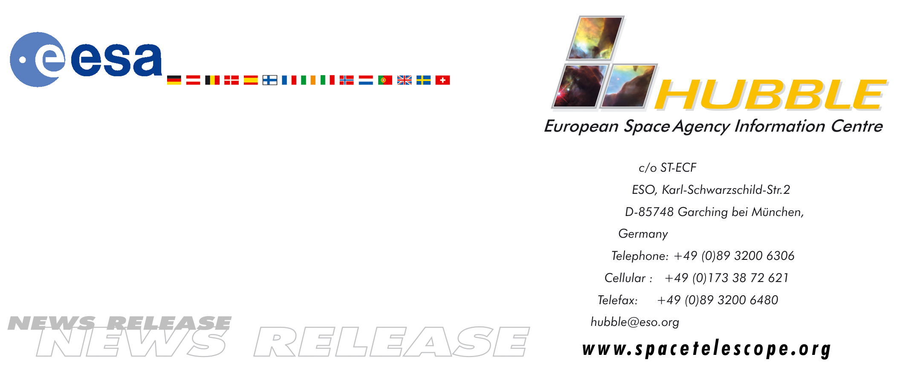

HEIC0001

News release:
Hubble European Space Agency Information Centre Opens

27-Apr-2000: For the Hubble Space Telescopes 10th anniversary on 27 April, ESA opens a new service. The Hubble European Space Agency Information Centre offers information about Hubble from a European perspective. Not only has Hubble's first 10 years produced a rich harvest of scientific results, it has also touched the man in the street with its beautiful images of the sky. With this initiative ESA shows its commitment to public outreach and to the communication of science. With an expected life time of 20 years, Hubble is now at the midpoint of its life. It has so far been one of the most successful scientific space missions, and the continuous maintenance and upgrade of the observatory through the Servicing Missions makes Hubble's next ten years appear even more promising.

The Hubble European Space Agency Information Centre is the Hubble & Next Generation Space Telescope dedicated contact point for the general public, the European media, and the European Hubble scientists.

The goal of Hubble European Space Agency Information Centre is to expose good European Hubble science to as broad an audience as possible: the public, the press and the scientific community.

The Hubble European Space Agency Information Centre provides the following services:

Dedicated web pages containing:
- News releases.
- The Hubble image archive.
- Background information about Hubble and astronomical phenomena
- Specially selected products like screensavers, interactive demonstrations, educational material etc.
- Printed material such as brochures, leaflets, posters and lithographs (printed pictures).
- Point-to-point contact for the press.
- Assistance to European Hubble scientists in publicising news and images

# # #

For more information, please contact:
Lars Lindberg Christensen
Hubble European Space Agency Information Centre, Garching, Germany
Phone: +49-(0)89-3200-6306
Cellular (24 hr): +49-(0)173-38-72-621
E-mail:lars@eso.org

