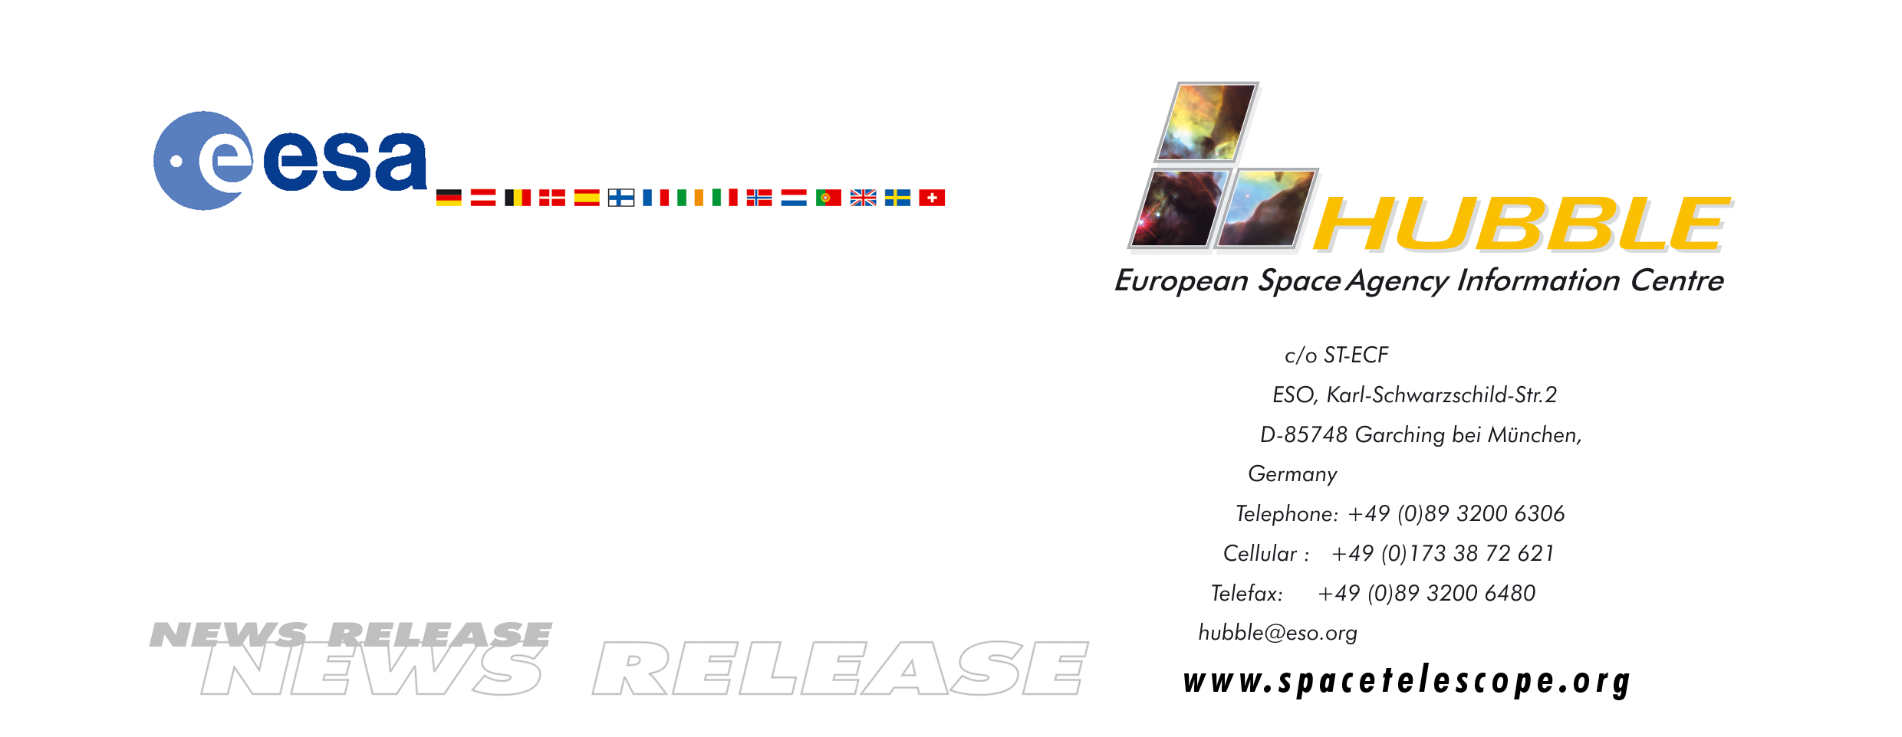

HEIC0009

News release:
Uncovering the mysteries of Jupiter’s aurora

14-Dec-2000 This week European and American researchers seize a once-in-a-lifetime opportunity to gather simultaneous observations from the NASA/ESA Cassini space mission and the NASA/ESA Hubble Space Telescope.

After years of waiting, an international team of researchers will receive an early Christmas present this week – a close-up look at the mysterious aurora surrounding Jupiter and a chance to gather valuable data about how the aurora behaves. The goal of these concerted efforts is to combine solar wind measurements with images to determine how the solar wind influences the aurorae around Jupiter. That information may in turn help researchers understand some of the differences between Jupiter and Earth.

As the NASA/ESA Cassini spacecraft makes its closest approach to Jupiter – approximately 10 million kilometres, compared with a distance of 600 million kilometres from Earth – researchers have a rare opportunity to gather data and images about the aurora simultaneously from Cassini and the NASA/ESA Hubble Space Telescope.
They will be able to conduct a real-time experiment from a distance of 600 million kilometres. The experiment uses instruments aboard Cassini to take direct measurements of the solar wind to determine the pressure exerted by these winds on Jupiter. Meanwhile Hubble will capture detailed images of the brilliant carpets of coloured light that are generated by the aurora. The measurements will be made in ultraviolet light using Hubble’s STIS instrument (Space Telescope Imaging Spectrograph).

“The aurora around Jupiter is vastly different from that experienced here on Earth. It’s almost 1000 times more energetic and appears to be much more complex. We know that solar winds control the Earth’s aurora, but we’re not sure how they influence the aurora on Jupiter,” says John T. Clarke, research scientist at the University of Michigan, USA, and team leader of the observations from Hubble.

The significance of these studies may extend far beyond our own Solar System, as Lotfi Ben-Jaffel from Institut d'Astrophysique de Paris in France explains: “Understanding the connection between the solar wind and Jupiter’s atmosphere and magnetosphere is a key to understanding extrasolar planets. More and more of these planets – named ‘Jupiters’ due to their large size - are discovered each month and they are all very close to their parent stars. This makes the auroral processes much more pronounced there than at Jupiter.”

The two spacecraft will collect data during the fortnight beginning December 14. The researchers will then begin to examine the images and a host of statistics about the solar wind, including velocity, temperature, pressure, density and magnetic field direction.

One of the European team members, English astronomer Michele Dougherty from Imperial College, UK explains: "We are really looking forward to this event. It will give us a unique chance of observing Jupiter's magnetic environment with a number of simultaneous observations. This is the first time at a planet other than the Earth that we will be able to take simultaneous measurements of the aurorae, along with 'in-situ' measurements of the magnetosphere and measurements out in the solar wind. On the sunlit side of Jupiter Cassini will take measurements of the solar wind as it makes it way towards Jupiter, and the Galileo spacecraft will also be participating in the campaign by taking measurements inside the magnetosphere. Hubble will provide the overview of the aurorae from the Earth."

A second observing campaign in January 2001 will compare images of the day-side aurora taken by Hubble with images from Cassini of Jupiter’s night side aurora, obtained just after Cassini has flown past Jupiter. The team will develop computer models that predict how the aurora operates and present its findings in early 2001.

In addition to the current mission, this experiment also serves as an important ‘test run’ for the Cassini spacecraft, originally launched by NASA and ESA back in 1997. It will be an important opportunity to test the spacecraft’s operational abilities as it heads for Saturn, where is expected to arrive in 2004.

# # #

Notes for editors
The Hubble Space Telescope is a project of international co-operation between NASA and ESA.

The Hubble team consists of scientists from the following institutions:
Institut d’Astrophysique de Paris (CNRS), France
Imperial College London, UK
Université de Liège, Belgium
University of Michigan, USA
Jet Propulsion Laboratory, USA
Goddard Spaceflight Center, USA
Los Alamos National Laboratory, USA
University of Colorado, USA
Southwest Research Institute, USA
University of California (UCLA), USA

The Cassini flyby event, dubbed the “Jupiter Millennium Flyby”, will be closely monitored by other space telescopes and instruments, Chandra and the Galileo spacecraft among others, as well as by ground-based telescopes.

For more information, please contact:
Lars Lindberg Christensen
Hubble European Space Agency Information Centre (Garching, Germany)
Phone: +49-(0)89-3200-6306
Cellular (24 hr): +49-(0)173-38-72-621
E-mail: lars@eso.org

Michele Dougherty
Imperial College, UK
Phone: +44 (0)20 7594 7770
E-mail: m.dougherty@ic.ac.uk

John Terrel Clarke
University of Michigan, USA
Phone: +001-734-647-3540
E-mail: clarke@umich.edu

