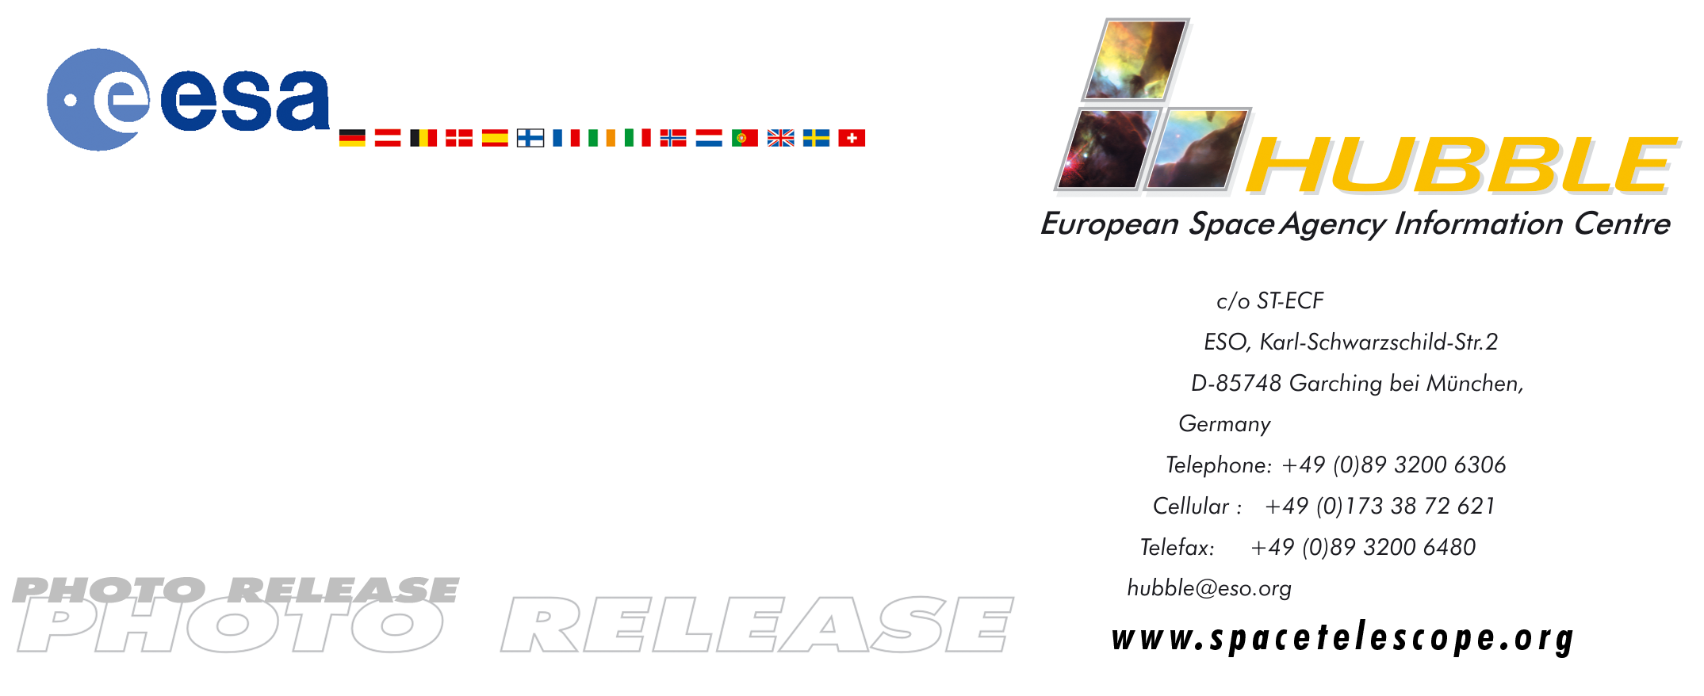

HEIC0101

Photo release:
Ants in space?
- Tantalising detail in ant-shaped nebula illuminates last moments of Sun-like stars

1-Feb-2001 Observed from ground-based telescopes, the so-called ‘ant nebula’ (Menzel 3, or Mz3) resembles the head and thorax of a common garden ant. This dramatic NASA/ESA Hubble Space Telescope image, showing 10 times more detail, reveals the ‘ant’s body’ as a pair of fiery lobes protruding from a dying, Sun-like star.

Hubble images directly challenge old ideas about planetary nebulae - the last stage in the life of Sun-like stars. This striking image has been assembled by the Hubble Heritage project and ESA from earlier images stored in the Hubble Archive. It is one of a series of images of planetary nebulae that have shown that our Sun’s fate will probably be more interesting, complex and striking than astronomers imagined even just a few years ago.

In particular, the image of Mz3 reveals intriguing symmetrical patterns in the turbulent ejection of gas from the dying star at the centre of Mz3, unlike the chaotic patterns expected from an ordinary explosion. Scientists using Hubble try to understand how a spherical star can produce such prominent, non-spherical symmetries in the gas that it ejects.

One possibility is that the central star of Mz3 has a closely orbiting companion that exerts strong gravitational tidal forces, which shape the outflowing gas. This model demands that the orbiting companion star be close to the dying star, at about the distance of the Earth from the Sun. At this distance, the orbiting companion star must be very close to the hugely bloated hulk of the dying star, or may even be orbiting inside it - a strange existence, not unlike that of the duck swallowed by the wolf in the old tale of “Peter and the Wolf”.

A second possibility is that as the dying star spins, its strong magnetic fields are twirled into complex shapes like strands of spaghetti. The glowing gases in the nebula are forced to trace out these complex patterns, allowing astronomers to ‘see’ the usually invisible magnetic field. Winds of charged particles moving at speeds up to 3.5 million km/hour away from the star – much like those in our local ‘solar wind’, but millions of times denser – are able to follow the twisted magnetic field on their way out into space. These dense winds can be rendered visible by ultraviolet light from the hot central star or from collisions with the ambient gas that excites the material into florescence.

No other planetary nebula observed by Hubble closely resembles Mz3. M2-9 is perhaps the most similar, but the outflow speeds in Mz3 are up to 10 times larger than those of M2-9. Interestingly, the very massive, young star, Eta Carinae, shows a very similar outflow pattern to that of Mz3.

Astronomers Bruce Balick (University of Washington, USA) and Vincent Icke (Leiden University, The Netherlands) used Hubble to observe this planetary nebula, Mz3, with the Wide Field Planetary Camera 2 in July 1997. A year later, astronomers Raghvendra Sahai and John Trauger of the Jet Propulsion Lab in California snapped pictures of Mz3 using slightly different filters. The intriguing image shown here is a composite of three filters from these two datasets.

# # #

Notes for editors
The Hubble Space Telescope is a project of international co-operation between ESA and NASA.

This photo release is issued jointly by ESA and NASA.

Acknowledgement: Bruce Balick (University of Washington, USA), Vincent Icke (Leiden University, The Netherlands), R. Sahai and John Trauger (Jet Propulsion Lab, USA).

Image credit: NASA, ESA and the Hubble Heritage Team (STScI/AURA)

For more information, please contact:
Lars Lindberg Christensen
Hubble European Space Agency Information Centre, Garching, Germany
Phone: +49-(0)89-3200-6306
Cellular (24 hr): +49-(0)173-38-72-621
E-mail: lars@eso.org

Raghvendra Sahai
Jet Propulsion Lab, Pasadena, USA
Phone: +1-818-354-0452
E-mail: sahai@bb8.jpl.nasa.gov

Bruce Balick
University of Washington, Seattle, USA
Phone: +1-206-543-7683
E-mail: balick@astro.washington.edu

Vincent Icke
Leiden University, Leiden, The Netherlands
Phone: +31-71-527-58-43
E-mail: icke@strw.LeidenUniv.nl

Howard Bond, Space Telescope Science Institute, Baltimore, USA
Phone: +1-410-338-4718
E-mail: bond@stsci.edu

