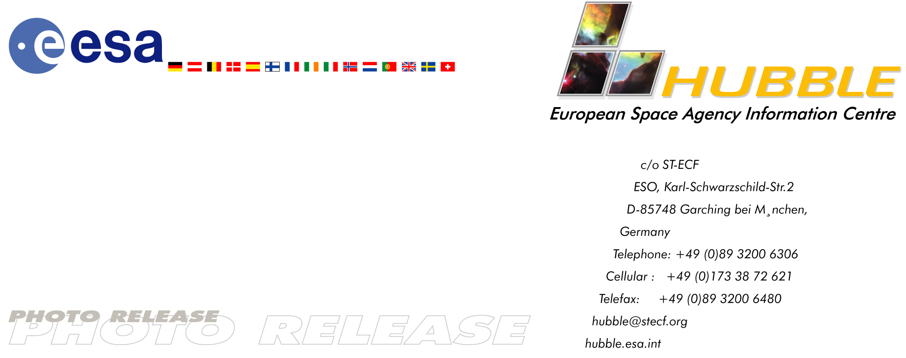

Heic0109: EMBARGOED UNTIL: 10:00 (CEST) TUESDAY 24 JULY, 2001

Photo Release: Surfing in Sagittarius – not for the faint-hearted!

24-July-2001 Hubble observations have revealed huge waves sculpted in the Red Spider Nebula. This warm and windy planetary nebula harbours one of the hottest stars in the Universe and its powerful stellar winds generate waves 100 billion kilometres high – intimidating for even the bravest space surfers.

The Red Spider Nebula, NGC 6537, is a striking ‘butterfly’ or bipolar (two-lobed) planetary nebula. Planetary nebulae are the glowing embers of ordinary stars, such as our Sun. At the end of their lives these stars expel most of their material into space, often forming a two-lobed structure as in the case of the Red Spider. This NASA/ESA Hubble Space Telescope image shows that the gas walls of the two lobed structures are not at all smooth, but rather are rippled in a complex way. These waves are driven by stellar winds radiating from the hot central star, much as a wind passing over a lake can generate waves on the water.

For many years astronomers from Europe and the USA have successfully used Hubble to study the variety of forms and shapes of planetary nebulae. The intricate pattern of waves of the Red Spider is an excellent example of the level of detail revealed by Hubble’s sharp eyes. Another example is the ‘S’-shaped symmetry of the lobes in the image – the lobes opposite each other appear similar. This is believed to be due to the presence of a companion to the hot central star (none of which are visible in the image).

An ideal place for potential space surfers?
The waves reach peaks 100 billion kilometres high and must have been produced by a powerful wind blowing with a speed of 2000-4500 kilometres per second (about 7-16 million km/hr). The waves themselves move outwards at a slower rate of 300 km/s (about 1 million km/hr). To add to these challenging climatic conditions, this nebula is not only windy, but also hot. The temperature of the gas waves is a scorching 10,000 K – much too warm for human surfers! Detailed investigations of the Hubble image have shown that the central white dwarf, the remaining compact core of the original star, must have a temperature of at least half a million degrees, making it one of the hottest stars known. It is so hot that it is invisible to Hubble’s eye and emits primarily in X-rays.

The waves are generated by supersonic shocks formed when the local gas is compressed and heated in front of the rapidly expanding lobes. Atoms caught in the shocks radiate the visible light seen in this image. The process appears to have been underway long enough to make the edges of the lobe walls look as if they have started to fracture into wave crests.

The Red Spider nebula is located about 3000 light-years away in the constellation of Sagittarius. The Hubble images were obtained on 12 September 1997 with the WPFC2 instrument (Wide Field and Planetary Camera 2) in five different filters. Here, light from sulphur ions is displayed in red (exposure time 900 s), nitrogen ions in orange (1200 s) and ionised hydrogen (H-alpha) in green (1240 s), while atomic oxygen is in light blue (1200 s) and ionised oxygen in dark blue (1000 s).

Credit: ESA & Garrelt Mellema (Leiden University, the Netherlands)

Notes for editors:
The Hubble Space Telescope is a project of international co-operation between ESA and NASA.

Members of the group of scientists involved in these observations are: Garrelt Mellema & Vincent Icke (Leiden University, the Netherlands) and Bruce Balick (University of Washington, USA).

Contacts:
Lars Lindberg Christensen
Hubble European Space Agency Information Centre, Garching, Germany
Phone: +49-89-3200-6306 (089 in Germany)
Cellular (24 hr): +49-173-38-72-621 (0173 in Germany)
E-mail: lars@eso.org

Garrelt Mellema
Leiden University
Phone: +31-71-527-5738
E-mail: mellema@strw.leidenuniv.nl

