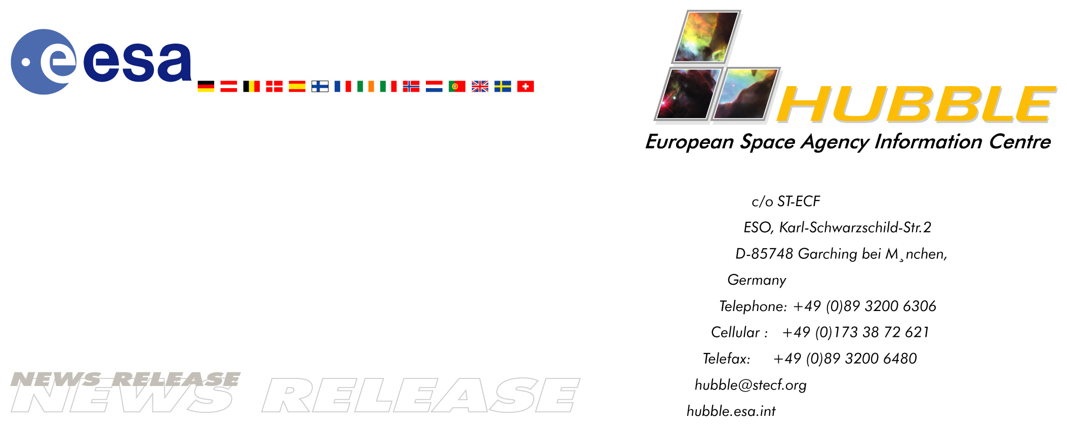

Heic0110: FOR IMMEDIATE RELEASE

News Release: Virtual Telescope Observes Record-Breaking Asteroid – New data show that “2001 KX76” is larger than Ceres

23-August-2001 Ceres, the first asteroid (minor planet) to be discovered in the Solar System, has held the record as the largest known object of its kind for two centuries. However, recent observations at the European Southern Observatory with the world’s first operational virtual telescope, Astrovirtel, have determined that the newly discovered distant asteroid “2001 KX76” is significantly larger, with a diameter of 1200 km, possibly even 1400 km.

Astrovirtel provides decisive data about 2001 KX76
By combining data from the world’s first operational ‘virtual telescope’, Astrovirtel, with that from a conventional telescope at the European Southern Observatory (ESO) at La Silla (Chile), European astronomers have determined the size of the newly found, remote asteroid, 2001 KX76.

Their measurements indicate that this icy rock has a diameter of at least 1200 km and is therefore larger than any other known asteroid in the Solar System. The previous record-holder, the asteroid Ceres, was also the first object of its type to be discovered – by the Italian astronomer Giuseppe Piazzi on January 1, 1801. Its diameter is about 950 km, relegating it to second place after holding the asteroid size record for two hundred years.

This conclusion is based on data from Astrovirtel, which has been operating at the ESO headquarters in Garching (Germany) for about one year. This advanced prototype science tool which in effect mimics a telescope provides astronomers with access to a wide variety of high-quality data. The first scientific results from Astrovirtel have allowed a substantial improvement of the accuracy of the computed orbit for 2001 KX76. It is now possible to confirm that this object is just outside that of the most remote known major planet Pluto. Further analysis carried out by the team seems to indicate that the orbit of 2001 KX76 is very similar to that of Pluto. Asteroid 2001 KX76 is even larger than Pluto’s moon Charon (diameter 1150 km), adding fuel to the fiery discussions concerning Pluto’s status as a
“major” or “minor” planet. The new data show that 2001 KX76 is about half the size of Pluto (diameter about 2300 km) and this increases the likelihood that there are other bodies still to be discovered in the outer Solar System that are similar in size to Pluto.

Observations of 2001 KX76
On July 2 2001, a group of American astronomers lead by Robert Millis (Lowell Observatory, Flagstaff, Arizona) announced the discovery of a seemingly rather large so-called Kuiper Belt Object, designated 2001 KX76. Objects of this type are icy planetary bodies that orbit beyond Neptune in the distant region of the Solar System known as the Kuiper Belt. More than 400 such objects are currently known and they are believed to be remnants of the formation of the Solar System and consequently amongst the most primitive and least-evolved objects available for study in the Solar System.

The first observations of 2001 KX76 were quite sparse, so the initial estimates of the size of the new asteroid were very uncertain. However, it did look large, possibly about the same size as the largest known asteroid, Ceres, the diameter of which had earlier been measured at about 950 km.

A team of German, Finnish and Swedish astronomers took the initiative to carry out a more accurate measurement of the size of 2001 KX76 within a unique collaboration between Astrovirtel and a conventional ESO telescope at the La Silla Observatory in Chile. The results show that this object is definitely the largest Kuiper Belt Object so far discovered.

Determining the size of a distant asteroid
In order to measure the size of any asteroid, it is necessary first to determine its orbit around the Sun, which gives its present distance from the Earth. The next step is to estimate its ‘albedo’, i.e. the percentage of incident sunlight reflected from its surface.
From these numbers and the measured, apparent brightness of the asteroid (as seen from the Earth), its diameter can finally be derived.

To determine the orbit of 2001 KX76 the group used Astrovirtel to apply automatic search software to scan through ‘old’ photographic plates obtained with various telescopes, as well as recent CCD observations made with the ESO Wide Field Imager (WFI) at the MPG/ESO 2.2 m telescope on La Silla (Chile).

The search was successful: the astronomers were able to find several photographic plates on which faint images of 2001 KX76 could be identified - some of these plates had been obtained as early as 1982. The exact sky positions were measured and with accurate positional data now available over a time span of no less than 18 years the team was able to compute the first, high-precision orbit of 2001 KX76. This also allowed to determine that the current distance from the Earth which turned out to be about 6.5 billion km corresponding to 43 times the distance of the Earth from the Sun, or nearly one-and-a-half times farther from the Sun than Neptune.

Combining this with a realistic assumption for the albedo of 2001 KX76 of 7 percent (corresponding to the albedo of another well-observed Kuiper Belt Object, Varuna, and comparable to that of our own Moon), a diameter of no less than 1200 km results. Assuming instead an albedo of 2001 KX76 of only 4 percent - a typical value for icy cometary nuclei - leads to the even larger (although less likely) value of 1400 km.

A real name for 2001 KX76
Thanks to the work of this group of astronomers, the orbit of 2001 KX76 may now be considered relatively secure and it may therefore soon receive a real name. Following astronomical tradition, the discoverers have the right to make a suggestion. The current custom dictates that a Kuiper Belt Object must be given a mythological name associated with creation. The name must then be confirmed by the International Astronomical Union before becoming official.

With a little bit of luck ...
The observations made with ESO’s Wide Field Imager were crucial for this work to succeed in that they allowed this object’s path to be tracked back in time. However, luck admittedly also played a key role. “These observations were originally made for a completely different project,” says Gerhard Hahn, team-leader for the project. “And we found the image of 2001 KX76 right at the edge of the WFI frames.”

Jenni Virtanen, another member of the team, adds: “And if we hadn’t used our powerful methods to improve the orbit we would still be searching through the archives.”

Arno Gnaedig, a German amateur astronomer and team member, performed the new and accurate position measurements and also calculated the new orbit on his home computer: “To me this is a wonderful example of the fruitful collaboration that can take place between well-equipped amateur astronomers and professional astronomers”, he says. “The Web and the access to ‘virtual observatories’ means that amateur astronomers – located far from any ‘real' professional telescopes – can also make important contributions.”

Following this success, the group is currently working on a study of the long-term orbital evolution of 2001 KX76, accounting for orbital uncertainties, in order to investigate the dynamical behaviour, and its relationship to both Pluto and Neptune.

The Astrovirtel co-ordinator, Piero Benvenuti, comments: “These results are thrilling for more than one reason. The latest in modern astronomical technology combined with a novel scientific procedure have been able to produce results that would otherwise have been very difficult to achieve. I am very delighted to see the first important scientific results materialise from our work with Astrovirtel.”

The “Virtual Observatory” concept, for which Astrovirtel is a prototype, is the start of a new era in astronomy. A larger study project called the “Astrophysical Virtual Observatory” is about to start within the Fifth EC Framework programme as a collaboration between ESO, ESA (ST-ECF), the University of Edinburgh (UK), CDS (Strasbourg, France), CNRS (Paris, France) and the University of Manchester (UK).

Credit: ESA, ESO, Astrovirtel & Gerhard Hahn (German Aerospace Center, DLR, Berlin)

Notes for editors:
This is a joint Press Release by the Space Telescope European Coordinating Facility (ST-ECF) and the European Southern Observatory (ESO).

Members of the group of scientists involved in these observations are: Gerhard Hahn (German Aerospace Center, DLR, Berlin), Claes-Ingvar Lagerkvist (Uppsala University, Sweden), Karri Muinonen, Jukka Piironen and Jenni Virtanen (University of Helsinki, Finland), Andreas Doppler and Arno Gnaedig (Archenhold Sternwarte, Berlin, Germany) and Francesco Pierfederici (ST-ECF/ESO).

Acknowledgments: Observations from Siding Spring Observatory (Digitized Sky Survey 1), and NEAT/JPL were also used in the orbit determination.

Contacts:
Lars Lindberg Christensen
Hubble European Space Agency Information Centre, Garching, Germany
Phone: +49-89-3200-6306 (089 in Germany)
Cellular (24 hr): +49-173-38-72-621 (0173 in Germany)
E-mail: lars@eso.org

Richard West
European Southern Observatory, Garching, Germany
Phone: +49-(0)89-3200-6276
E-mail: rwest@eso.org

Gerhard Hahn, Berlin, Germany
German Aerospace Center, DLR
Phone: +49-30-670-55-417 (030 in Germany)
E-mail: gerhard.hahn@dlr.de

Karri Muinonen
Observatory, University of Helsinki, Finland
Phone: +358-(0)9-19122941
E-mail: Karri.Muinonen@Helsinki.Fi

Claes-Ingvar Lagerkvist
Uppsala Astronomical Observatory, Sweden
Phone: +46-18-471-5977
E-mail: classe@astro.uu.se

