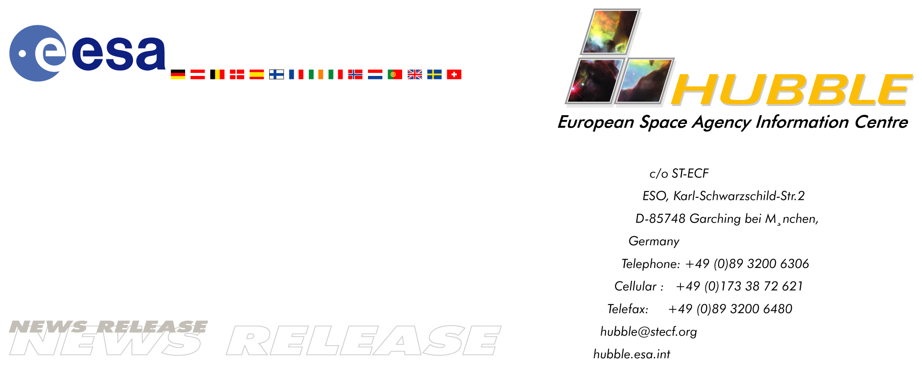

Heic0117: FOR RELEASE 10:00 (CET) FRIDAY 14 DECEMBER, 2001

News release:
Students Follow in the Footsteps of Scientists
- ESA/ESO Astronomy Exercises Provide a Taste of Real Astronomy

14-December-2001 The “ESA/ESO Astronomy Exercise Series”, published today, allows students to gain exciting hands-on experience in astronomy by making realistic calculations with data obtained by the world’s best telescopes. The students measure and calculate the distances and ages of astronomical objects, among the most basic problems in modern astrophysics, using observations made by the NASA/ESA Hubble Space Telescope and ESO’s Very Large Telescope.

Astronomy at the frontline of education
The subject of astronomy plays an increasingly important role within education. This is not coincidental - this particular field of basic science is very attractive to young people. Its exploratory and visual nature tickles youthful minds and the vast expanse of the Universe harbours many unknown secrets that are waiting to be discovered. The beautiful and intriguing images brought back by high-tech telescopes and instruments from the enormous terra incognita out there are natural works of art that invite contemplation as well as interpretation.

Astronomy is a broadly interdisciplinary field, providing ample opportunities for interesting educational angles into many different fields of fundamental science, from physics, chemistry and mathematics, to applied research in opto-mechanics, detectors and data handling, and onwards into the humanities.

Reacting to the current need for innovative, high-quality educational materials, the European Space Agency (ESA) and the European Southern Observatory
(ESO) have together produced this series of astronomical exercises for use in European high schools.

In the footsteps of scientists
The "ESA/ESO Astronomy Exercise Series" has just been published, on the web and in print. These exercises allow 16-19 year old students to gain exciting hands-on experience in astronomy, making realistic calculations with data obtained by some of the world's best telescopes, the NASA/ESA Hubble Space Telescope and ESO's Very Large Telescope (VLT). Carefully prepared by astronomers and media experts, these exercises enable the students to measure and calculate fundamental properties like the distances to and the ages of different kinds of astronomical objects.

The prime object of the series is to present various small projects that will transmit some of the excitement and satisfaction of scientific discovery to students. By performing the well-structured projects, the students also gain first-hand experience in the application of scientific methods that require only basic geometrical and physical knowledge. They use ideas and techniques described in recent front-line scientific papers and are able to derive results that compare well with those obtained from the much more sophisticated analyses done by the scientists.

Focus on basic themes
The first four exercises focus on measurements of distances in the Universe, one of the most basic problems in modern astrophysics.

The students apply different methods to determine the distance of astronomical objects such as the supernova SN 1987A, the spiral galaxy Messier 100, the Cat’s Eye Planetary Nebula and the globular cluster Messier 12. With these results it is possible to make quite accurate estimates of the age of the Universe and its expansion velocity, without the use of computers or sophisticated software.

Students can also perform ‘naked-eye photometry’ by measuring the brightness of stars on two VLT images (taken through blue and green optical filters, respectively). They can then construct the basic luminosity-temperature relation (the “Hertzsprung-Russell Diagram”) providing a superb way to gain insight into fundamental stellar physics.

Six booklets
The exercises are now available on the web and in six booklets (100 pages in total), entitled:
- “General Introduction” (an overview of the exercise series),
- “Toolkits" (explanation of basic astronomical and mathematical techniques) ,
- “Exercise 1: Measuring the Distance to Supernova 1987A”,
- “Exercise 2: The Distance to Messier 100 as Determined by Cepheid Variable Stars”,
- “Exercise 3: Measuring the Distance to the Cat's Eye Nebula” and
- “Exercise 4: Measuring a Globular Star Cluster's Distance and Age”.

Each of the four exercises begins with a background text, followed by a series of questions, measurements and calculations. The exercises can be used either as texts in a traditional classroom format or for independent study as part of a project undertaken in smaller groups.

The booklets are sent free-of-charge to high-school teachers on request and may be downloaded as PDF files from the web site. More exercises will follow in the future.

Image credit: the European Space Agency and the European Southern Observatory.

# # #

Notes for editors
This is a joint Press Release by the European Southern Observatory (ESO) and the Hubble European Space Agency Information Centre.

The Hubble Space Telescope is a project of international co-operation between ESA and NASA.

Contacts
Arntraud Bacher
The ESO Educational Office
Karl-Schwarzschild Str. 2, D-85748 Garching bei München, Germany
Phone: +49-(0)89-3200-6309 (089 within Germany)
Fax: +49-(0)89-320 32 62 (089 within Germany)
E-mail: abacher@eso.org

Lars Lindberg Christensen
Hubble European Space Agency Information Centre, Garching, Germany
Phone: +49-89-3200-6306 (089 within Germany)
Cellular (24 hr): +49-173-38-72-621 (0173 within Germany)
E-mail: lars@eso.org

Richard West
ESO PR, Garching, Germany
Phone: +49-(0)89-3200-6276 (089 within Germany)
E-mail: rwest@eso.org

