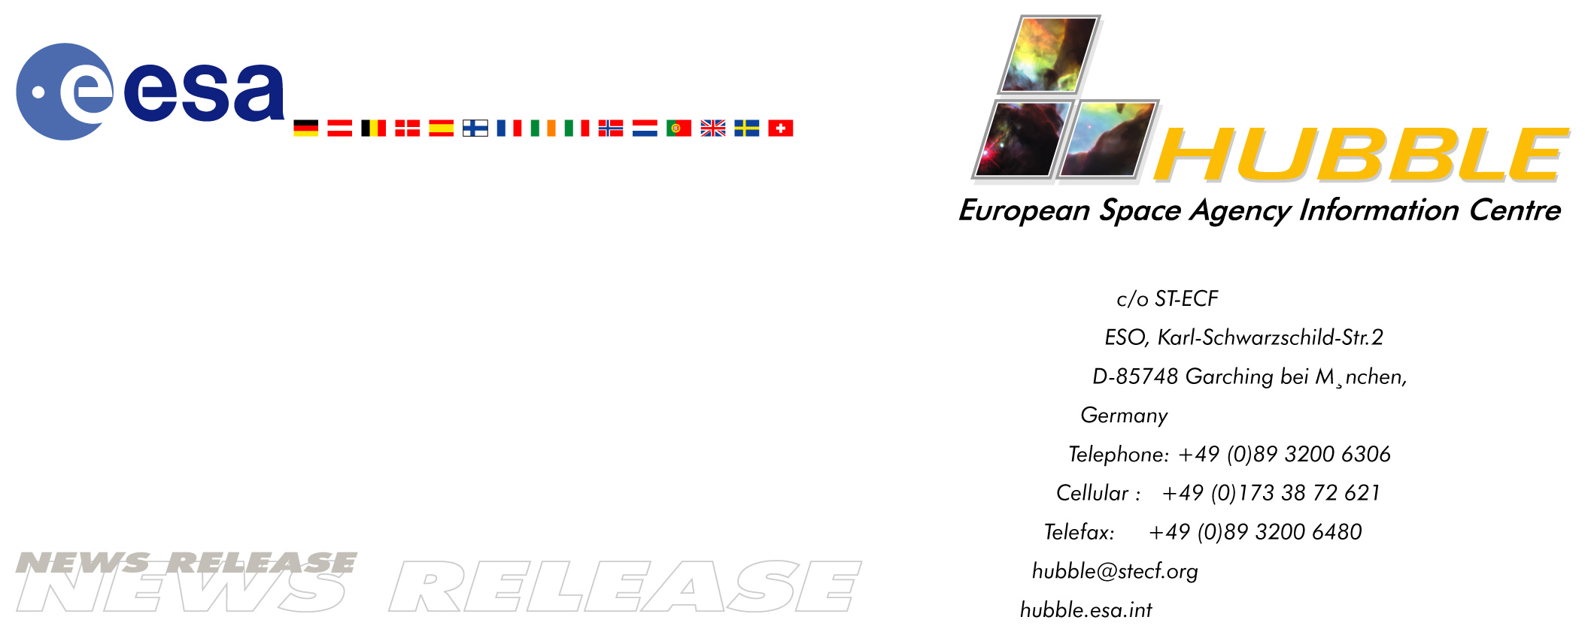

Heic0204: News release
European Faint Object Camera on Hubble sets world record
- celebrating the successes of ESA's sharp-sighted camera

07-Mar-2002 When the new Advanced Camera for Surveys was installed on the ESA/NASA Hubble Space Telescope Thursday noon (European time) it replaced the European Space Agency's Faint Object Camera (FOC). The FOC has spent a record-breaking 4340 days (nearly 12 years) in space. Throughout its 12-year lifetime the FOC has celebrated a number of successes. Most notable are the first direct image of the atmosphere of a star, the first sighting of surface details on the planet Pluto, and the first image of an 'exposed' black hole.

The foremost scientific capability of the FOC was its very high angular resolution, which in practice meant that it could produce extremely sharp images. The superb image quality of the FOC was put to use in providing unique close-up views of nearly every class of astronomical objects. The camera has, among many other things, revealed the first surface details on the planet Pluto, made the first direct images of the atmospheres of giant stars like Betelgeuse, the first image of an 'exposed' black hole, shown circumstellar material around exploding stars, like Nova Cygni, and around supernovae like SN 1987A.

The FOC has with its sharp eye penetrated the inner enigmatic cores of active galaxies, where black holes with masses up to several million times that of our Sun are hiding. Another impressive achievement was the discovery of the movement of material in the jets which extend from the galaxy M87. The galaxy is at a distance of 45 million light-years and FOC observations of the jet over a number of years allowed the detection and measurement of the motion of the jet's knots. The FOC measurements have been a key element for the understanding of this impressive phenomenon. The FOC's special ability to detect the very faintest ultraviolet light was extensively used to make spectra of very distant quasars. This effort ultimately resulted in a breakthrough in cosmology - the first detection of singly ionised helium in the medium between the galaxies.

Peter Jakobsen, ESA's current project scientist for the FOC, comments on the scientific successes of this sharp-sighted camera: "Although the images obtained with the FOC have only rarely been as photogenic as the famous images from the Wide Field and Planetary Camera 2, it has in my opinion served the astronomical community well and brought home its share of scientific 'firsts'."

ESA's former project scientist for the FOC, Duccio Macchetto, expresses his feelings at the removal of the FOC: "Naturally you get very involved with a project this important, but I don't feel sad at all. To me the FOC has reached the end of a very productive life." And he continues: "The collaboration in ultraviolet and optical astronomy between NASA and ESA that was started with the IUE [International Ultraviolet Explorer], and that has had as its centrepiece the Hubble project, has really been exemplary, and we hope to continue in this way in the future. As Hubble's results show, everyone enjoys the fruits of a 'big science' project like this: scientists, industry and the general public. I look forward to a close and fruitful collaboration between ESA and NASA in the NGST project."

# # #

Notes for editors
The Hubble Space Telescope is a project of international co-operation between ESA and NASA.

The new Advanced Camera for Surveys on the ESA/NASA Hubble Space Telescope was installed Thursday 7 March 2002 during a 7.5-hour-long spacewalk. This fantastic new instrument replaced the last of Hubble's original instruments, the Faint Object Camera (FOC), delivered by the European Space Agency. FOC will, at the time of the Space Shuttle's landing on 12 March 2002 (around 08:00 UT), have spent 4340 days in space since the launch on 24 April 1990. This is the longest time that any piece of hardware has spent in space before being retrieved and returned to the ground.

The prime contractor for ESA's Faint Object Camera was Astrium (Germany - formerly Dornier System, Germany). The Hubble Space Telescope is a project of international cooperation between ESA and NASA.

Project contact
Duccio Macchetto
ESA/Space Telescope Science Institute, Baltimore, USA
Phone: +1-410-338-4790/4861
E-mail: macchetto@stsci.edu

PR contact
Lars Lindberg Christensen
Hubble European Space Agency Information Centre, Garching, Germany
Phone: +49-89-3200-6306 (089 in Germany) (until 12.03.02 +1 301 286 6467)
Cellular (24 hr): +49-173-38-72-621 (0173 in Germany)
E-mail: lars@eso.org

