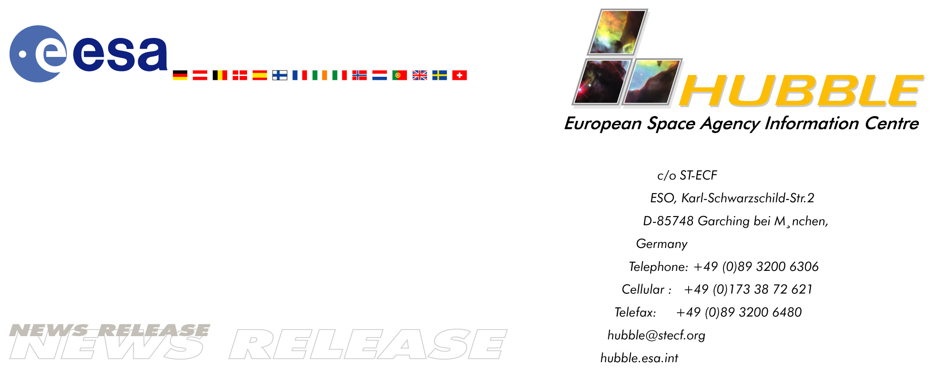

HEIC0310: EMBARGOED UNTIL: 21:00 (CEST) 5 September, 2003

News release:
Hubble assists Rosetta comet mission

5-September-2003 Results from the NASA/ESA Hubble Space Telescope played a major role in preparing ESA’s ambitious Rosetta mission for its new target, comet 67P/Churyumov-Gerasimenko. Hubble has been the critical tool in measuring precisely the size, shape and rotational period of the comet. Information that is essential if Rosetta is to rendezvous with a comet and then drop down a probe, something never before attempted and yet a major step to elucidating solar system origins.

Hubble’s observations from March 2003 revealed that comet 67P/Churyumov-Gerasimenko (67P/C-G) is approximately five-by-three kilometres, and shaped like a rugby ball on which it is possible to land. ESA Mission scientists needed to know the exact size of the solid nucleus to adapt the mission to the comet’s gravity. "Although 67P/C-G is roughly three times larger than the original Rosetta target, its highly elongated shape should make landing on its nucleus feasible, now that measures are in place to adapt the lander package to the new scenario," says Dr. Philippe Lamy of the Laboratoire d'Astronomie Spatiale in France. Lamy is presenting the Hubble results on comet 67P/C-G at the annual meeting of the Division of Planetary Sciences of the American Astronomical Society in California, USA, on 5 September 2003.

Mission scientists began considering the new target when the Rosetta mission's launch date was postponed. The delay made the original target comet, 46P/Wirtanen, no longer easily reachable. But scientists did not have enough information on the backup comet, 67P/C-G, and sought data from the largest telescopes. Using a technique developed over the past decade by Lamy, Imre Toth (Konkoly Observatory, Hungary), and Harold Weaver (Johns Hopkins University Applied Physics Laboratory, Laurel, USA), the team snapped 61 Hubble images of comet 67P/C-G over an interval of 21 hours between March 11 and 12, 2003. Hubble's Wide Field Planetary Camera 2 isolated the comet's nucleus from the coma, the diffuse cloud of gas and dust surrounding it, and quickly provided the missing figures. The telescope showed that the nucleus is ellipsoidal and also measured its rotation rate of approximately 12 hours.

Rosetta's launch is currently planned for February 2004, with a rendezvous with the comet about 10 years later.

# # #
Notes for editors
The team is composed of P.L. Lamy and L. Jorda (Laboratoire d'Astronomie Spatiale, France), I. Toth (Konkoly Observatory, Hungary), and H.A. Weaver (Johns Hopkins University Applied Physics Laboratory). The movie simulation of the Hubble results is provided by Mikko Kaasalainen (University of Helsinki, Finland) and Pedro Gutierrez (Laboratoire d'Astronomie Spatiale, France).

The observations were made possible through a special program approved by the Director of the Space Telescope Science Institute, S. Beckwith.

Image credit: NASA, European Space Agency and Philippe Lamy (Laboratoire d'Astronomie Spatiale, France)

For more information, please contact:
Philippe Lamy
Laboratoire d'Astronomie Spatiale, France
Cellular: +33-630-14-92-33 (Californian time zone)
E-mail: lamy@astrsp-mrs.fr

Lars Lindberg Christensen
Hubble European Space Agency Information Centre, Garching, Germany
Tel: +49-89-3200-6306 (089 within Germany)
Cellular (24 hr): +49-173-3872-621 (0173 within Germany)
E-mail: lars@eso.org

Ray Villard
Space Telescope Science Institute, Baltimore, MD, USA
Tel: +1-410-338-4514)
E-mail: villard@stsci.edu

Michael Buckley
Johns Hopkins University Applied Physics Laboratory, Laurel, MD, USA
Tel: +1-443-778-7536
E-mail: michael.buckley@jhuapl.edu

