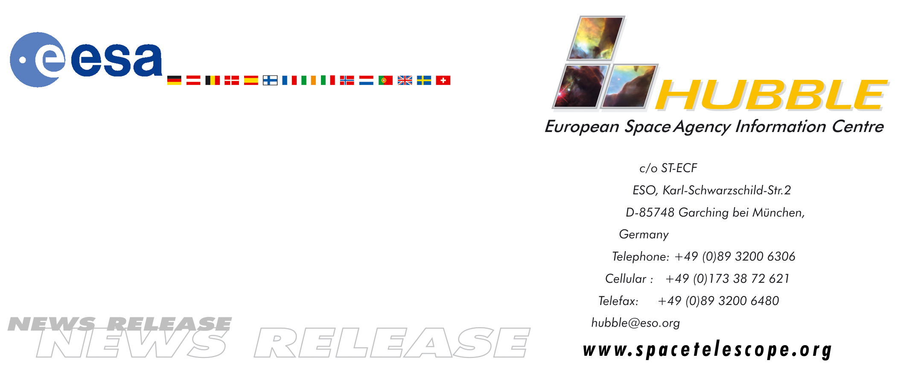

HEIC0410: FOR RELEASE 15:00 (CEST)/9:00 AM EDT 15 June, 2004

News release:
First direct measurement of the mass of ultra-cool brown dwarf binary

15-June-2004 An international team of astronomers using the world's biggest telescopes have directly measured the mass of an ultra-cool brown dwarf star and its companion dwarf star for the first time. Barely the size of the planet Jupiter, the dwarf star weighs in at just 8.5 percent of the mass of our Sun. This is the first ever mass measurement of a dwarf star belonging to a new stellar class of very low mass ultra-cool dwarf stars. The observation is a major step towards our understanding of the types of objects that occupy the gap between the lightest stars and the heaviest planets.

In 2000 the NASA/ESA Hubble Space Telescope detected a brown dwarf companion around the star named 2MASSW J0746425+2000321. In the subsequent four years the system was tracked by the NASA/ESA Hubble Space Telescope, the European Southern Observatory’s Very Large Telescope (Chile), the Gemini North (Hawaii) and the Keck Telescopes (Hawaii). The masses of the stars could be measured from the orbital motions of the two objects. With a mass of 8.5% of our Sun's mass, the primary star is precariously close to the theoretical minimal fusion limit, which is 7.5 percent of our Sun's mass. Objects below this limit are called brown dwarfs, failed stars or even super-planets, as their properties are more similar to those of large Jupiter-type planets than stars. The brown dwarf is measured to be 6.6 percent of the Sun's mass, and thereby too puny to shine by nuclear fusion.

The mass measurements were made by an international team of astronomers led by Hervé Bouy from the Max-Planck-Institut für Extraterrestrische Physik/ESO, Germany and the Observatoire de Grenoble, France; Eduardo Martin (Instituto de Astrofisica de Canarias, Spain); and Wolfgang Brandner (Max Planck Institut für Astronomie, Germany).

To be able to compute the masses of the two stars, detailed observations of each component of the binary system were required and interpreted using the latest stellar evolutionary models. Because both objects are very close to each other, telescopes capable of providing high-resolution images were needed. The separation on the sky between the two stars is only about 1/20000 of a degree – similar to the size of a 1 Euro coin seen at a distance of about 25 km.

Furthermore, observations had to be performed over a long period of time (four years) to follow the motion of both objects around each other. Very accurate measurements of the relative position of the individual components were made, so that the full 10-year orbit of the binary system could be reconstructed. Once the orbit was known, the astronomers were able to use Kepler’s laws, first formulated four centuries ago, and some simple high school math to compute the total mass of the system. The distance between the two objects is around 2.5 times the distance from the Sun to the Earth.

Once the total mass of the system was known, very precise measurements of the brightness and temperature of each object taken by Hubble made it possible to split the total mass into the masses of the primary star and the brown dwarf companion.

Both components of the binary system belong to the L spectral class that includes the lowest mass stars and the highest mass brown dwarfs in our solar neighbourhood. This spectral class was discovered in 1997 and was added to the spectral classification that had remained unchanged for half a century. The L class is characterized by the formation of dust grains in the object's atmosphere, which dramatically changes the visible-light spectrum.

Theoretically predicted for a long time, these sub-stellar objects called "brown dwarfs" were only discovered in 1995. Indirect techniques were conceived to identify brown dwarf candidates from their brightness and colour. However, the mass measurement is the only direct way to classify an object as a brown dwarf. Binary brown dwarfs are especially challenging because they are faint and lie very close to each other. Hubble or large ground-based telescopes using adaptive optics to cancel out atmospheric blur are therefore required to perform such studies.

The study opens a new chapter in the investigation of the dust-filled molecule-rich atmospheres of objects in the transitional zone between the lightest stars and the heaviest exoplanets.

# # #

Notes for editors
The science team consists of Hervé Bouy (Max-Planck-Institut für Extraterrestrische Physik/ESO Garching, Germany/LAOG, Grenoble, France), G. Duchêne (LAOG, Grenoble, France/UCLA, USA), R. Köhler and W. Brandner (Max-Planck-Institut für Astronomie, Heidelberg, Germany), Jérome Bouvier and Xavier Delfosse (LAOG, Grenoble, France), Eduardo Martin (IAC, Spain), Andrea Ghez and C. McCabe (UCLA, USA), Françoise Allard and Isabelle Baraffe (CRAL, Lyon, France), G. Basri (UC Berkeley, USA), and L. Close (Steward Observatory, Arizona, USA). Their science paper appears in the Journal of Astronomy and Astrophysics on 15 June 2004.

Animations of the discovery and general Hubble Space Telescope background footage are available from http://www.spacetelescope.org/videos/html/heic0410a.html

The Hubble Space Telescope is a project of international cooperation between ESA and NASA.

Image credit: ESA/NASA and Herve Bouy (Max-Planck-Institut für Extraterrestrische Physik/ESO, Germany)

For more information, please contact:
Hervé Bouy
Max-Planck-Institut für Extraterrestrische Physik/ESO, Garching, Germany
Cellular: +49 (0)171 380 7274
Tel: +49 (0)89 30000 3317
E-mail: hbouy@mpe.mpg.de

Lars Lindberg Christensen
Hubble European Space Agency Information Centre, Garching, Germany
Tel: +49 (0)89 3200 6306
Cellular (24 hr): +49 (0)173 3872 621
E-mail: lars@eso.org

Henri Boffin
European Southern Observatory, Garching, Germany
Tel: +49 (0)89 3200 6276
E-mail: hboffin@eso.org

Jennifer Martin
Journal Astronomy & Astrophysics, France
Tel: +33 1 4329 0541
Email: aanda.paris@obspm.fr

