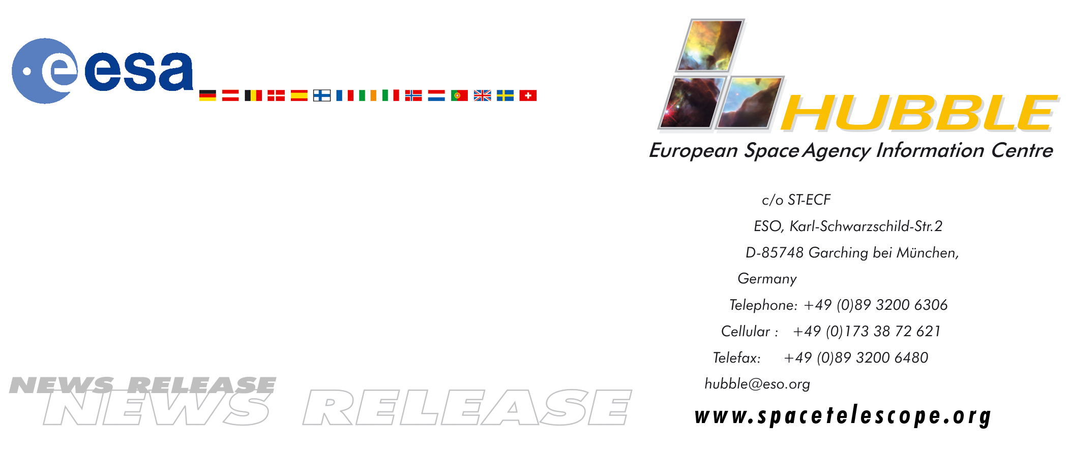
HEIC0510: FOR RELEASE 10:00 (CEST)/04:00 AM EDT 8 August, 2005

News release:
FITS for fun – create spectacular pictures in minutes

8-August-2005 With the release of version 2 of the popular ESA/ESO/NASA Photoshop FITS Liberator image processing software it is now easier and faster than ever before to create colour images from raw observations from for instance the NASA/ESA Hubble Space Telescope, ESA's XMM-Newton and the NASA Spitzer Space Telescope.

In July 2004 imaging scientists at the European Space Agency, the European Southern Observatory and NASA released a free plug-in called the ESA/ESO/NASA Photoshop FITS Liberator. FITS stands for Flexible Image Transport System and this single file format archives nearly all images of stars, nebulae and galaxies produced by major telescopes around the world. Until July 2004, this file format was only accessible to very few people other than the scientists themselves using highly specialized image processing tools.

With the release of version 2 of the FITS Liberator today it has become even easier to create colour images from raw observations. You can literally create spectacular pictures like the iconic Hubble image “Pillars of Creation” in a matter of minutes.

Since the release of v.1 in July 2004, more than 50,000 laypeople, educators and amateur astronomers have started using the Liberator. The FITS Liberator has also become industry standard for the professional imaging scientists at the European Space Agency, the European Southern Observatory and NASA.

Version 2 of the FITS Liberator has been improved in several areas, including:
- FITS images with up to 4 billion greyscales (32 bit) can be processed.
- FITS images with up to 500 million pixels or more can be processed (100 times larger than standard images from a digital camera).
- With a re-designed workflow and improved user interface, it is easier to use.
- With the new options for advanced scaling and stretching, the images can be tuned and tweaked for optimal results.
- A whole section of the plug-in is dedicated to inputting metadata, i.e. information about the image and what it shows. Metadata will be important for future efforts to make archives of colour images better accessible.
- The user has access to a text version of the original FITS header.

Apart from the great advantages of an interactive workflow, the Liberator enables creation of images with improved quality as the many greyscales in the original observations are preserved. This gives added detail in the shadows and an increased gamut (colour space) in the finished colour images.

The ESA/ESO/NASA Photoshop FITS Liberator v.2 will be released today and is freely available for download from:
http://www.spacetelescope.org/projects/fits_liberator

Some of the most enthusiastic members of the FITS Liberator community, such as amateur astronomer Davide De Martin, have created a huge online digital library of their own best Liberator images. They compete with each other to create the most stunning astronomical imagery. These images can be found via the link above.

# # #

Notes for editors
The ESA/ESO/NASA Photoshop FITS Liberator v.2 works on Windows PCs and Macs (OS X 10.3+) and is optimised for Photoshop CS2, but also works in CS (16 bit colour), Photoshop Elements 3.0 (16 bit colour), Photoshop 7.0 (only 15 bit support) and Photoshop Elements 2 (only 8 bit support).

FITS is an abbreviation for Flexible Image Transport System and has been a standard since 1982 and is recognized by the International Astronomical Union.

The team that produced the ESA/ESO/NASA Photoshop FITS Liberator consists of:
Project Lead: Lars Lindberg Christensen (lars@eso.org)
Development Lead: Lars Holm Nielsen
Core Functionality: Kaspar K. Nielsen
Engine and GUI: Teis Johansen
Scientific support: Robert Hurt
Technical support and testing: Robert Hurt, Zolt Levay, Bob Fosbury and Richard Hook.

The ESA/ESO/NASA Photoshop FITS Liberator uses NASA’s CFITSIO library.

Adobe and Photoshop are either registered trademarks or trademarks of Adobe Systems Incorporated in the United States and/or other countries.

If you wish to no longer receive these News and Photo Releases, please send an e-mail to distribution@spacetelescope.org with your name.

Image credit: Davide De Martin (http://www.skyfactory.org/), the ESA/ESO/NASA Photoshop FITS Liberator & Digitized Sky Survey 2

For more information, please contact:

Lars Lindberg Christensen
Hubble European Space Agency Information Centre, Garching, Germany
Tel: +49-(0)89-3200-6306
Cellular: +49-(0)173-3872-621
E-mail: lars@eso.org

Lars Holm Nielsen
Tel: +45-3288-6866
Cellular: +45-2215-5180
E-mail: lars@hankat.dk

Robert L. Hurt
Spitzer Science Center, IPAC, Caltech, Pasadena, USA
Tel: +1-626-395-1825
E-mail: hurt@ipac.caltech.edu

Zolt Levay
Space Telescope Science Institute, Baltimore, USA
Tel: +1-410-338-4907
E-mail: levay@stsci.edu

