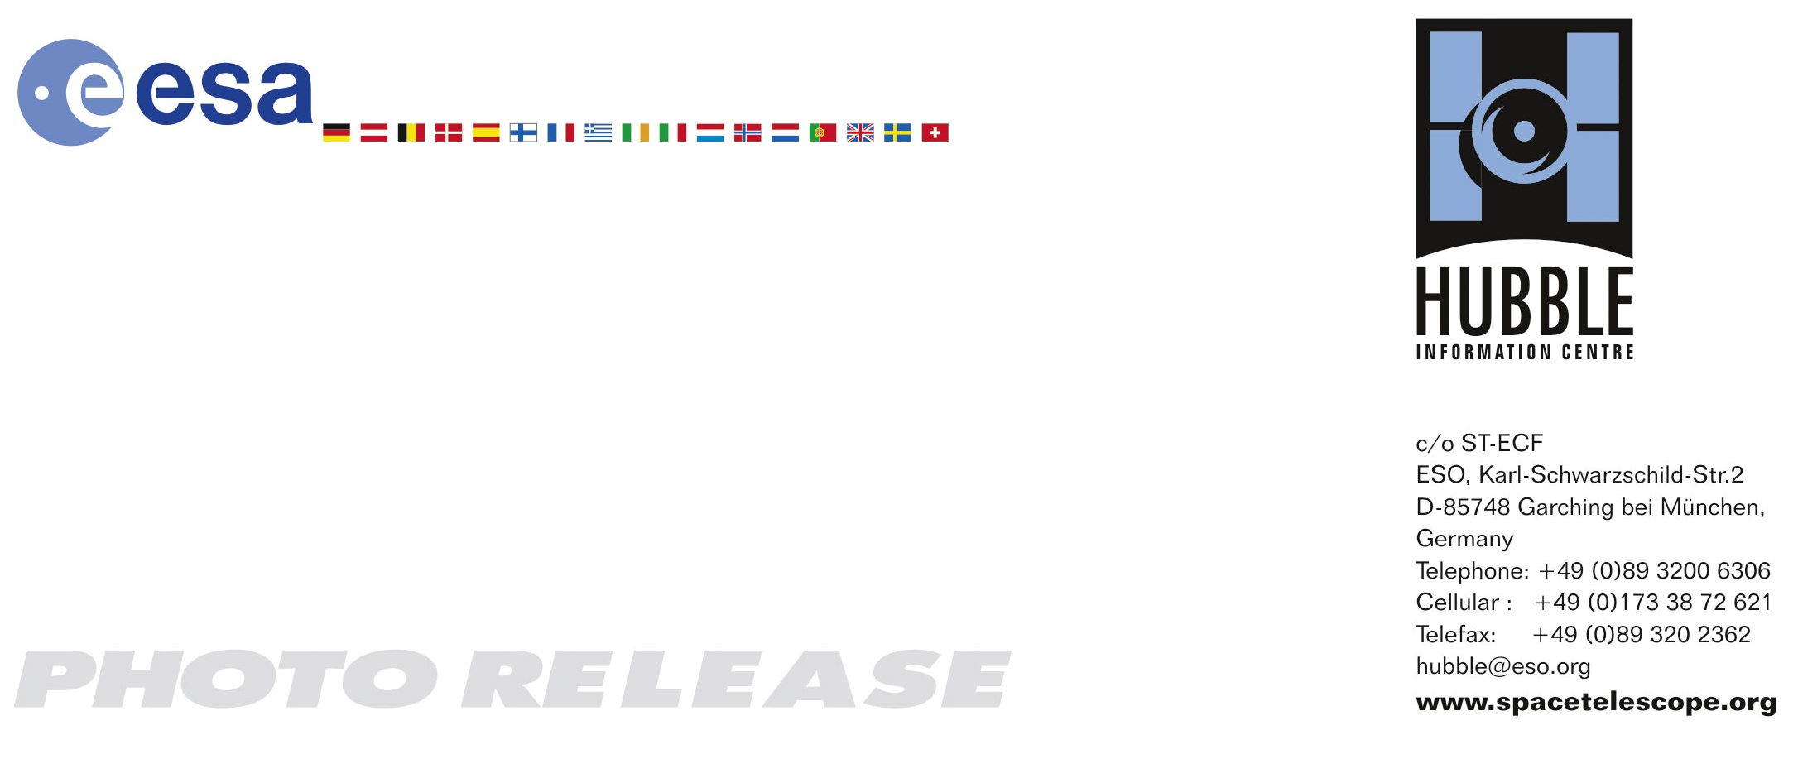

HEIC0604: FOR RELEASE 15:00 (CEST)/9:00 AM EDT 24 April, 2006

Photo release:
Happy sweet sixteen, Hubble Space Telescope

24-April-2006 To celebrate the NASA-ESA Hubble Space Telescope’s 16 years of success, the two space agencies are releasing this mosaic image of the magnificent starburst galaxy, Messier 82 (M82). It is the sharpest wide-angle view ever obtained of M82, a galaxy remarkable for its webs of shredded clouds and flame-like plumes of glowing hydrogen blasting out from its central regions.

Throughout the central region of Messier 82, young stars are being born 10 times faster than they are inside in our Milky Way Galaxy. These numerous hot new stars emit not only radiation but also particles called a stellar wind. Stellar winds streaming from these hot new stars also have combined to form a fierce galactic superwind. This superwind compresses enough gas to make millions more stars and blasts out towering plumes of hot ionised hydrogen gas, above and below the disk of the galaxy (seen in red in the image).

In M82 young stars are crammed into tiny but massive star clusters which themselves then congregate by the dozen to make the bright patches or "starburst clumps" seen in the central parts of M82. The individual clusters in the clumps can only be distinguished in the ultra-sharp Hubble images. Most of the pale objects sprinkled around the main body of M82 that look like fuzzy stars are actually star clusters about 20 light-years across and containing up to a million stars.

The rapid rate of star formation in this galaxy will eventually be self-limiting. When star formation becomes too vigorous, it will destroy the material needed to make more stars and the starburst will subside, probably in a few tens of millions of years.

Located 12 million light-years away, M82 appears high in the northern spring sky in the direction of the constellation Ursa Major, the Great Bear. It is also called the "Cigar Galaxy" because of the elongated elliptical shape produced by the tilt of its starry disk relative to our line of sight.

The observation was made in March 2006 with the Advanced Camera for Surveys’ Wide Field Channel. Astronomers assembled this 6-image composite mosaic by combining exposures taken with four coloured filters that capture starlight from visible and infrared wavelengths as well as the light from the glowing hydrogen filaments.

Hubble was launched on April 24, 1990, aboard the space shuttle Discovery.

# # #

Notes for editors
The Hubble Space Telescope is a project of international cooperation between ESA and NASA.

Image Credit: NASA, ESA and the Hubble Heritage Team (STScI)

Acknowledgment: M. Mountain (STScI), P. Puxley (National Science Foundation), and J. Gallagher (University of Wisconsin)

If you wish to no longer receive these News and Photo Releases, please send an email to distribution@spacetelescope.org with your name.

For more information, please contact:

Jay Gallagher
University of Wisconsin, USA
Tel:+1-608-263-2456
E-mail: jsg@astro.wisc.edu

Lars Lindberg Christensen
Hubble/ESA, Garching, Germany
Tel: +49-89-3200-6306
Cellular: +49-173-3872-621
E-mail: lars@eso.org

Ray Villard
Space Telescope Science Institute, Baltimore, USA
Tel: +1-410-338-4514
E-mail: villard@stsci.edu

Keith Noll
Space Telescope Science Institute, Baltimore, USA
Tel: +1-410-338-1828
E-mail: noll@stsci.edu

