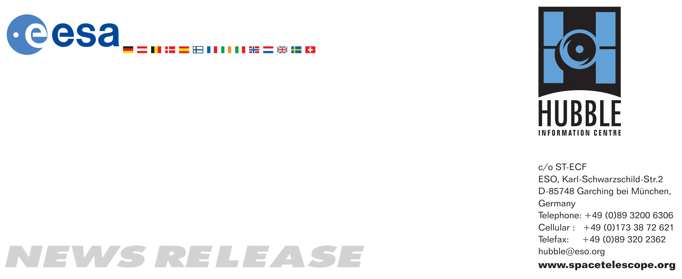

HEIC0618: FOR IMMEDIATE RELEASE 17:00 (CEST)/11:00 AM EDT 31 October, 2006

News release:
New Hubble Servicing Mission to upgrade instruments

31-October-2006 After more than a decade of fascinating discoveries, The Hubble Space Telescope will soon be given the new beginning that it deserves. Today, NASA has decided to approve a Space Shuttle mission to repair and upgrade the observatory, despite new Shuttle safety rules formulated after the Columbia disaster that would normally rule out such a rescue mission.

The history of the NASA/ESA Hubble Space Telescope is dominated by the familiar sharp images and amazing discoveries that have had an unprecedented scientific impact on our view of the world and our understanding of the Universe. Nevertheless, such important contributions to science and mankind have only been possible as result of regular upgrades and enhancements to Hubble’s instrumentation.

After the Columbia Space Shuttle disaster in 2003, ESA is now thankful that NASA has approved another Servicing Mission despite the absence of a safe haven for the crew. Hubble’s orbit would not allow the Shuttle crew to take refuge aboard the International Space Station and wait for rescue if the Space Shuttle were damaged at launch.

However the Shuttle has been successfully launched on three missions since Columbia, confirming that the numerous improvements since the disaster have established a high level of safety for the vehicle and its crew. After assessing the pros and cons, NASA Administrator Mike Griffin has given the green light for Hubble Servicing Mission 4 – the fifth Servicing Mission to Hubble.

“There is never going to be an end to the science that we can do with a machine like Hubble”, says David Southwood, ESA’s Director of Science. “Hubble is our way of exploring our origin. Everyone should be proud that there is a European element in it and that we all are part of its success at some level.”

This Servicing Mission will not only ensure that Hubble can function for perhaps as much as another ten years, it will also increase its capabilities significantly in key areas. This highly visible mission is expected to take place in 2008 and will feature several space walks.

As part of the upgrade, two new scientific instruments will be installed: the Cosmic Origins Spectrograph and the Wide Field Camera 3. Each has advanced technology sensors that will dramatically improve Hubble’s potential for discovery and enable it to observe the faint light from the youngest stars and galaxies in the Universe. With such an astounding increase in its science capabilities, this outer space observatory will continue to penetrate the most distant corners of space and reveal breathtaking phenomena.

“Today Hubble is producing more science than ever before in its history. Astronomers are requesting five times more observing time than that available to them” says Bob Fosbury, Head of ESA’s Hubble group. “The new instruments will open completely new windows on the Universe. Extraordinary observations are planned in the coming years, including some of the most fascinating physical phenomena ever seen: Investigations of planets around other stars, digging deeper into the ancestry of our Milky Way and above all, gaining a much deeper insight into the evolution of the Universe.”

Around the same time that the Shuttle lifts off for the Servicing Mission, ESA will launch Herschel, the orbiting telescope with the largest mirror ever deployed in space. Herschel will complement Hubble in the infrared part of the spectrum and is an ESA mission with NASA participation.

Hubble’s direct successor, the James Webb Space Telescope — a project of international collaboration between NASA, ESA and the Canadian Space Agency, is scheduled for launch in 2013, but without another servicing mission Hubble would stop working many years before this.

Instead of being left at the mercy of its aging instruments, the Hubble Space Telescope will now be given the new life it deserves. In the hope that more discoveries from Hubble will help unlock the mysteries of the Universe, astronauts will make a fifth trip to the world’s most powerful visual light observatory and increase its lifespan and scientific power.

# # #

Notes for editors
The Hubble Space Telescope is a project of international cooperation between ESA and NASA.

If you wish to no longer receive these News and Photo Releases, please send an email to distribution@spacetelescope.org with your name.

For more information, please contact:

Sergio Volonté
ESA Head of the science planning and community coordination office
ESA HQ Paris
Tel: +33-1-5369-7103
E-mail: Sergio.Volonte@esa.int

Lars Lindberg Christensen
Hubble/ESA, Garching, Germany
Tel: +49-89-3200-6306
Cellular: +49-173-3872-621
E-mail: lars@eso.org

