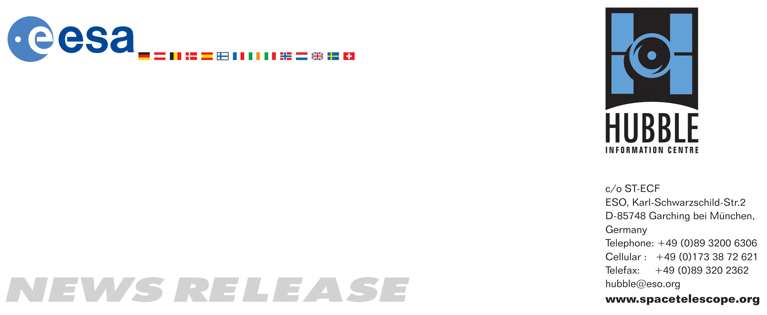

HEIC0713: EMBARGOED UNTIL 15:00 (CEST)/9:00 AM EDT 22 August, 2007
http://www.spacetelescope.org/news/html/heic0713.html

News release:
Hubble teams with Google to bring the cosmos down to Earth

22-August 2007 Imagine cruising the heavens from your desktop and seeing all the spectacular images from the NASA/ESA Hubble Space Telescope. Exploding stars and faraway galaxies are just a mouse click away today through Sky in Google Earth.

Sky in Google Earth is produced by Google, and can be downloaded free of charge with the newest version of Google Earth. Several elements of Sky in Google Earth have been contributed by the European Space Agency.

With Sky in Google Earth, you can travel across the vastness of the night sky, making tour stops at 125 of the most popular Hubble images. Though these celestial objects are far away from Earth, you can reach them in a few seconds with Sky in Google Earth.

Travelers can begin their celestial tour by selecting "Switch to Sky" from the "view" drop-down menu in Google Earth. From here, an object, such as the Eagle Nebula - the so-called pillars of creation - or even a category, such as colliding galaxies, can be selected from a menu. You will first get a view of the sky showing the constellations surrounding your selected object. As you zoom in, the constellations disappear and your chosen object emerges from the background.

The Hubble images are set within a background of real stars and galaxies taken by two powerful visible-light surveys of the heavens, the Digitized Sky Survey and the Sloan Digital Sky Survey. The Digitized Sky Survey comprises photographic surveys of nearly the entire sky and contains about a million objects. The Sloan survey comprises images of hundreds of millions of much fainter objects and covers more than a quarter of the sky.

“The Hubble Space Telescope is a project of international cooperation between ESA and NASA and we are now happy to see that, thanks to Hubble’s wonderful images, Sky in Google Earth is like having the heavens at your fingertips,” said Fernando Doblas, Head of ESA Communication.

Pretty pictures aren’t the only part of this versatile program. Click on the icon of the HubbleSite logo and information on the object taken from the press release or photo caption will appear. Sky in Google Earth also will provide links to the Hubble news database and other Hubble information. Newly released Hubble pictures will be added to the Sky in Google Earth program as soon as they are issued. Sky in Google Earth is produced by Google, through a partnership with Space Telescope Science Institute, Hubble’s home institute.

# # #

Notes for editors
The Hubble Space Telescope is a project of international cooperation between ESA and NASA.
Image credit: NASA, ESA, Digitized Sky Survey Consortium, and the STScI-Google Partnership

If you wish to no longer receive these News and Photo Releases, please send an email to distribution@spacetelescope.org with your name.

For more information, please contact:

Lars Lindberg Christensen
Hubble/ESA, Garching, Germany
Tel: +49-(0)89-3200-6306
Cellular: +49-(0)173-3872-621
E-mail: lars@eso.org

Fernando Doblas
Head of ESA Communication, Paris, France
Tel: +33-1-5369-8028
E-mail: Fernando.Doblas@esa.int

Carol Christian/Alberto Conti
Space Telescope Science Institute, Baltimore
+1-410-338-4764/4534
E-mail: carolc@stsci.edu/aconti@stsci.edu

Ray Villard
Space Telescope Science Institute, Baltimore, USA
Tel: +1-410-338-4514
E-mail: villard@stsci.edu

