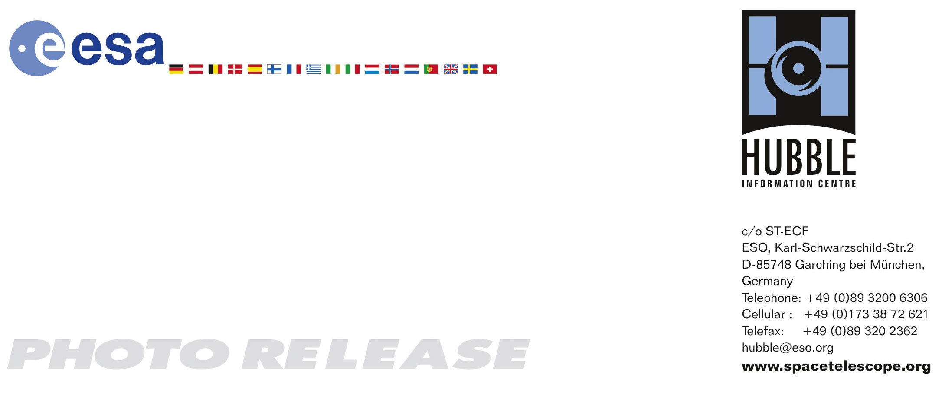

HEIC0810: EMBARGOED UNTIL 15:00 (CEST)/09:00 AM EDT 24 April, 2008
http://www.spacetelescope.org/news/html/heic0810.html

Photo release: Galaxies gone wild!

24-April-2008 Fifty nine new images of colliding galaxies make up the largest collection of Hubble images ever released together. As this astonishing Hubble atlas of interacting galaxies illustrates, galaxy collisions produce a remarkable variety of intricate structures.

Interacting galaxies are found throughout the Universe, sometimes as dramatic collisions that trigger bursts of star formation, on other occasions as stealthy mergers that result in new galaxies. A series of 59 new images of colliding galaxies has been released from the several terabytes of archived raw images from the NASA/ESA Hubble Space Telescope to mark the 18th anniversary of the telescope’s launch. This is the largest collection of Hubble images ever released to the public simultaneously.

Galaxy mergers, which were more common in the early Universe than they are today, are thought to be one of the main driving forces for cosmic evolution, turning on quasars, sparking frenetic star births and explosive stellar deaths. Even apparently isolated galaxies will show signs in their internal structure that they have experienced one or more mergers in their past. Each of the various merging galaxies in this series of images is a snapshot of a different instant in the long interaction process.

Our own Milky Way contains the debris of the many smaller galaxies it has encountered and devoured in the past, and it is currently absorbing the Sagittarius dwarf elliptical galaxy. In turn, it looks as if our Milky Way will be subsumed into its giant neighbour, the Andromeda galaxy, resulting in an elliptical galaxy, dubbed "Milkomeda", the new home for the Earth, the Sun and the rest of the Solar System in about two billion years time. The two galaxies are currently rushing towards each other at approximately 500,000 kilometres per hour.

Cutting-edge observations and sophisticated computer models, such as those pioneered by the two Estonian brothers Alar Toomre and Juri Toomre in the 1970s, demonstrate that galaxy collisions are far more common than previously thought. Interactions are slow stately affairs, despite the typically high relative speeds of the interacting galaxies, taking hundreds of millions of years to complete. The interactions usually follow the same progression, and are driven by the tidal pull of gravity. Actual collisions between stars are rare as so much of a galaxy is simply empty space, but as the gravitational webs linking the stars in each galaxy begin to mesh, strong tidal effects disrupt and distort the old patterns leading to new structures, and finally to a new stable configuration.

The pull of the Moon that produces the twice-daily rise and fall of the Earth’s oceans illustrates the nature of tidal interactions. Tides between galaxies are much more disruptive than oceanic tides for two main reasons. Firstly, stars in galaxies, unlike the matter that makes up the Earth, are bound together only by the force of gravity. Secondly, galaxies can pass much closer to each other, relative to their size, than do the Earth and the Moon. The billions of stars in each interacting galaxy move individually, following the pull of gravity from all the other stars, so the interwoven tidal forces can produce the most intricate and varied effects as galaxies pass close to each other.

Typically the first tentative sign of an interaction will be a bridge of matter as the first gentle tugs of gravity tease out dust and gas from the approaching galaxies (IC 2810). As the outer reaches of the galaxies begin to intermingle, long streamers of gas and dust, known as tidal tails, stretch out and sweep back to wrap around the cores (NGC 6786, UCG 335, NGC 6050). These long, often spectacular, tidal tails are the signature of an interaction and can persist long after the main action is over. As the galaxy cores approach each other their gas and dust clouds are buffeted and accelerated dramatically by the conflicting pull of matter from all directions (NGC 6621, NGC 5256). These forces can result in shockwaves rippling through the interstellar clouds (ARP 148). Gas and dust are siphoned into the active central regions, fuelling bursts of star formation that appear as characteristic blue knots of young stars (NGC 454). As the clouds of dust build they are heated so that they radiate strongly, becoming some of the brightest (luminous and ultraluminous) infrared objects (APG 220) in the sky.

These objects emit up to several thousand billion times the luminosity of our Sun. They are the most rapidly star-forming galaxies in today’s Universe and are linked to the occurrence of quasars. Unlike standard spiral galaxies like the Milky Way, which radiate from stars and hot gas distributed over their entire span of perhaps 100 000 light-years, the energy in luminous and ultraluminous infrared galaxies is primarily generated within their central portion, over an extent of 1000 to 10,000 light-years. This energy emanates both from vigorous star formation processes, which can generate up to a few hundred solar masses of new stars per year (in comparison, the Milky Way generates a few solar masses of new stars per year), and from massive accreting black holes, a million to a billion times the mass of the Sun, in the central region.

Intense star formation regions and high levels of infrared and far-infrared radiation are typical of the most active central period of the interaction and are seen in many of the objects in this release. Other visible signs of an interaction are disruptions to the galaxy nuclei (NGC 3256, NGC 17). This disruption may persist long after the interaction is over, both for the case where a larger galaxy has swallowed a much smaller companion and where two more closely matched galaxies have finally separated.

Most of the 59 new Hubble images are part of a large investigation of luminous and ultraluminous infrared galaxies called the GOALS project (Great Observatories All-sky LIRG Survey). This survey combines observations from Hubble, the NASA Spitzer Space Observatory, the NASA Chandra X-Ray Observatory and NASA Galaxy Explorer. The Hubble observations are led by Professor Aaron S. Evans from the University of Virginia and the National Radio Astronomy Observatory (USA).

A number of the interacting galaxies seen here are included in the The Atlas of Peculiar Galaxies, a remarkable catalogue produced by the astronomer Halton Arp in the mid-1960s that built on work by B.A. Vorontsov-Velyaminov from 1959. Arp compiled the catalogue in a pioneering attempt to solve the mystery of the bizarre shapes of galaxies observed by ground-based telescopes. Today, the peculiar structures seen by Arp and others are well understood as the result of complex gravitational interactions.

# # #

Notes for editors
The Hubble Space Telescope is a project of international cooperation between ESA and NASA.

Credit: NASA, ESA, the Hubble Heritage Team (STScI/AURA)-ESA/Hubble Collaboration and A. Evans (University of Virginia, Charlottesville/NRAO/Stony Brook University)

Acknowledgements for this photo release:
- Project lead: Lars Lindberg Christensen
- Image processing: Davide de Martin (ESA/Hubble) and Zolt Levay (STScI)
- Cosmetic cleaning: Amit Kapadia, Nuno Marques, Maximilian Kaufl (ESA/Hubble)
- Colour correction and cosmetic adjustments: Zolt Levay (STScI) & Martin Kornmesser (ESA/Hubble)
- HST Principle Investigator: A. Evans (University of Virginia, Charlottesville/NRAO/ Stony Brook), and the PIs of Hubble Proposals 9735, 11091, 6276, 10575, 7129, 7467, 6438.
- Astronomical processing pipeline: The STScI ACS team
- Data Archiving and pipeline implementation: The ESO/ST-ECF Archive and the STScI Archive
- Textual information: Ana Margarida Lopes, Will Gater, Anne Rhodes, Raquel Yumi Shida & Lars Lindberg Christensen (ESA/Hubble)
- Web products: Raquel Yumi Shida (ESA/Hubble) & Stratis Kakadelis (STScI)

If you no longer wish to receive these News and Photo Releases, please send an e-mail to distribution@spacetelescope.org with your name.

For more information, please contact:
Aaron Evans
Department of Astronomy
University of Virginia, Charlottesville, USA
E-mail: aaron.evans@stonybrook.edu

Lars Lindberg Christensen
Hubble/ESA, Garching, Germany
Tel: +49-(0)89-3200-6306
Cellular: +49-(0)173-3872-621
E-mail: lars@eso.org

Ray Villard
Space Telescope Science Institute, Baltimore, USA
Tel: +1-410-338-4514
villard@stsci.edu

