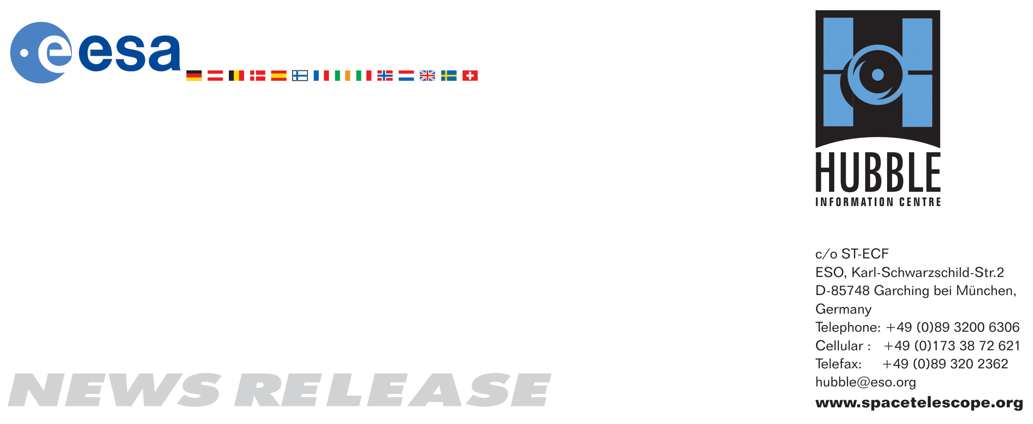

HEIC0817: EMBARGOED UNTIL 19:00 (CEST)/01:00 pm EDT 20 August, 2008
http://www.spacetelescope.org/news/html/heic0817.html

News release: Hubble sees magnetic monster in erupting galaxy

20-Aug 2008 The Hubble Space Telescope has found the answer to a long-standing puzzle by resolving giant but delicate filaments shaped by a strong magnetic field around the active galaxy NGC 1275. It is the most striking example of the influence of these immense tentacles of extragalactic magnetic fields, say researchers.

NGC 1275 is one of the closest giant elliptical galaxies and lies at the centre of the Perseus Cluster of galaxies. It is an active galaxy, hosting a supermassive black hole at its core, which blows bubbles of radio-wave emitting material into the surrounding cluster gas. Its most spectacular feature is the lacy filigree of gaseous filaments reaching out beyond the galaxy into the multi-million degree X-ray emitting gas that fills the cluster.

These filaments are the only visible-light manifestation of the intricate relationship between the central black hole and the surrounding cluster gas. They provide important clues about how giant black holes affect their surrounding environment.

A team of astronomers using the NASA/ESA Hubble Space Telescope Advanced Camera for Surveys have for the first time resolved individual threads of gas which make up the filaments. The amount of gas contained in a typical thread is around one million times the mass of our own Sun. They are only 200 light-years wide, are often surprisingly straight, and extend for up to 20 000 light-years. The filaments are formed when cold gas from the galaxy’s core is dragged out in the wake of rising bubbles blown by the black hole.

It has been a challenge for astronomers to understand how the delicate structures withstood the hostile high-energy environment of the galaxy cluster for more than 100 million years. They should have heated up, dispersed, and evaporated over a very short period of time, or collapsed under their own gravity to form stars. Even more puzzling is the fact that they haven’t been ripped apart by the strong tidal pull of gravity in the cluster’s core.

A new study led by Andy Fabian from the University of Cambridge, UK, published in Nature on 21 August 2008 proposes that the magnetic fields hold the charged gas in place and resist forces that would distort the filaments. This skeletal structure has been able to contain and suspend these peculiarly long threads for over 100 million years. “We can see that the magnetic fields are crucial for these complex filaments - both for their survival and for their integrity”, said Fabian.

The new Hubble data also allowed the strength of the magnetic fields in the filaments to be determined from their size. Thinner filaments are more fragile, requiring stronger magnetic fields for support. However, the finer the filaments, the more difficult they are to observe.

The filamentary system in NGC 1275 provides the most striking example of the workings of extragalactic magnetic fields so far and is a spectacular by-product of the complex interaction between the cluster gas and the supermassive black hole at the galaxy’s heart. Similar networks of filaments are found around many other, even more remote, central cluster galaxies. They cannot be observed in anything like the detail of NGC 1275, so the team will apply the understanding gained here to interpret observations of these more distant galaxies.

# # #

Notes for editors
The Hubble Space Telescope is a project of international cooperation between ESA and NASA.

The authors of the science paper are: A.C. Fabian, R.M. Johnstone, J.S. Sanders (University of Cambridge, UK), C.J. Conselice (University of Nottingham, UK), C.S. Crawford (University of Cambridge, UK), J.S. Gallagher III (University of Wisconsin, USA) and E. Zweibel (University of Wisconsin, USA)

Image credit: NASA, ESA & Andy Fabian (University of Cambridge, UK)

If you wish to no longer receive these News and Photo Releases, please send an e-mail to distribution@spacetelescope.org with your name.

For more information, please contact:

Andy Fabian
Institute of Astronomy, University of Cambridge, UK
Tel: +44-1223-3375-09
E-mail: acf@ast.cam.ac.uk

Lars Lindberg Christensen
Hubble/ESA, Garching, Germany
Tel: +49-89-3200-6306
Cell: +49-173-3872-621
E-mail: lars@eso.org

