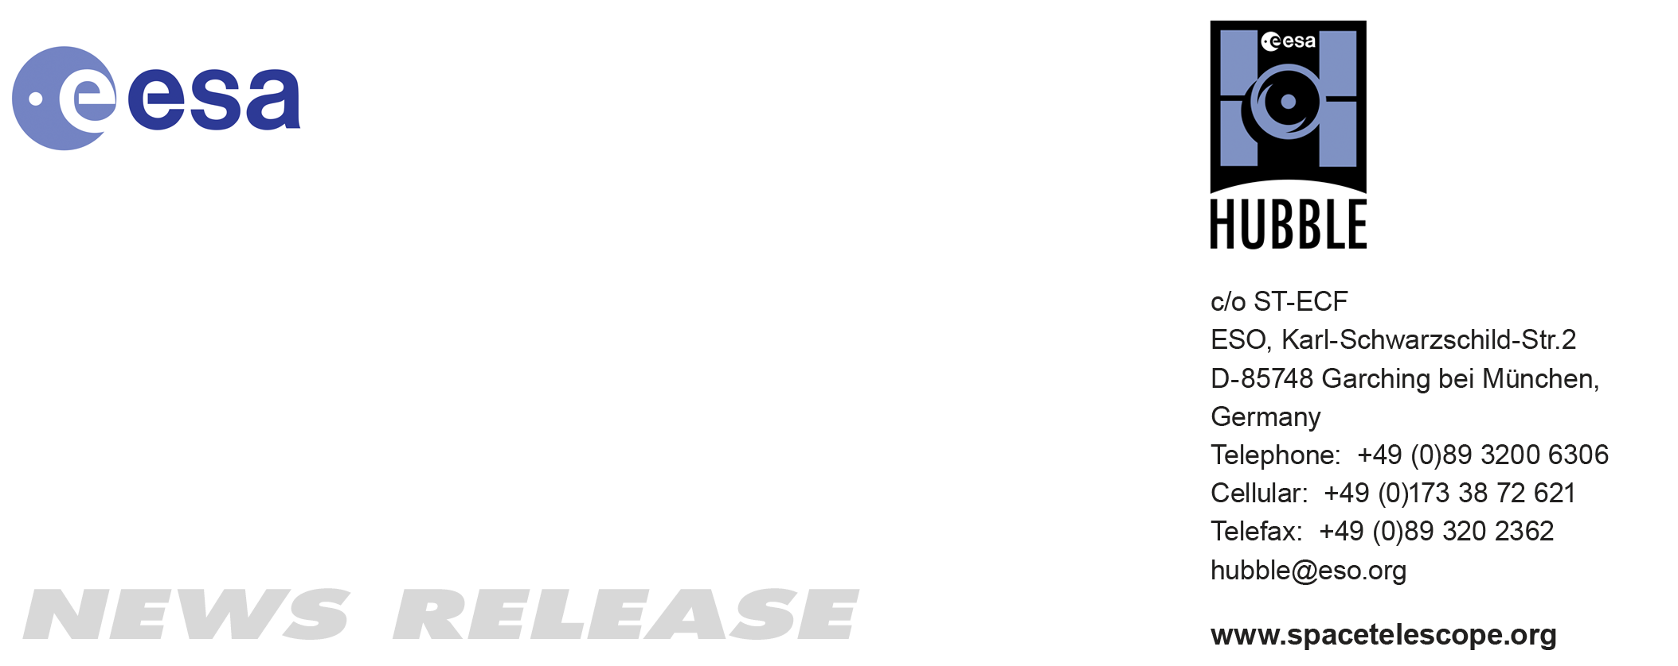

HEIC1005: EMBARGOED UNTIL 12:00 (CET)/07:00 am EDT 25 Mar, 2010
http://www.spacetelescope.org/news/html/heic1005.html

News release: Hubble confirms cosmic acceleration with weak lensing

25-Mar 2010 A new study led by European scientists presents the most comprehensive analysis of data from the most ambitious survey ever undertaken by the NASA/ESA Hubble Space Telescope. These researchers have, for the first time ever, used Hubble data to probe the effects of the natural gravitational “weak lenses” in space and characterise the expansion of the Universe.

A group of astronomers [1], led by Tim Schrabback of the Leiden Observatory, conducted an intensive study of over 446 000 galaxies within the COSMOS field, the result of the largest survey ever conducted with Hubble. In making the COSMOS survey, Hubble photographed 575 slightly overlapping views of the same part of the Universe using the Advanced Camera for Surveys (ACS) onboard Hubble. It took nearly 1000 hours of observations.

In addition to the Hubble data, researchers used redshift [2] data from ground-based telescopes to assign distances to 194 000 of the galaxies surveyed (out to a redshift of 5). “The sheer number of galaxies included in this type of analysis is unprecedented, but more important is the wealth of information we could obtain about the invisible structures in the Universe from this exceptional dataset,” says co-author Patrick Simon from Edinburgh University.

In particular, the astronomers could “weigh” the large-scale matter distribution in space over large distances. To do this, they made use of the fact that this information is encoded in the distorted shapes of distant galaxies, a phenomenon referred to as weak gravitational lensing [3]. Using complex algorithms, the team led by Schrabback has improved the standard method and obtained galaxy shape measurements to an unprecedented precision. The results of the study will be published in an upcoming issue of Astronomy and Astrophysics.

The meticulousness and scale of this study enables an independent confirmation that the expansion of the Universe is accelerated by an additional, mysterious component named dark energy. A handful of other such independent confirmations exist. Scientists need to know how the formation of clumps of matter evolved in the history of the Universe to determine how the gravitational force, which holds matter together, and dark energy, which pulls it apart by accelerating the expansion of the Universe, have affected them. “Dark energy affects our measurements for two reasons. First, when it is present, galaxy clusters grow more slowly, and secondly, it changes the way the Universe expands, leading to more distant — and more efficiently lensed — galaxies. Our analysis is sensitive to both effects,” says co-author Benjamin Joachimi from the University of Bonn. “Our study also provides an additional confirmation for Einstein’s theory of general relativity, which predicts how the lensing signal depends on redshift,” adds co-investigator Martin Kilbinger from the Institut d'Astrophysique de Paris and the Excellence Cluster Universe.

The large number of galaxies included in this study, along with information on their redshifts is leading to a clearer map of how, exactly, part of the Universe is laid out; it helps us see its galactic inhabitants and how they are distributed. “With more accurate information about the distances to the galaxies, we can measure the distribution of the matter between them and us more accurately,” notes co-investigator Jan Hartlap from the University of Bonn. “Before, most of the studies were done in 2D, like taking a chest X-ray. Our study is more like a 3D reconstruction of the skeleton from a CT scan. On top of that, we are able to watch the skeleton of dark matter mature from the Universe’s youth to the present,” comments William High from Harvard University, another co-author.

The astronomers specifically chose the COSMOS survey because it is thought to be a representative sample of the Universe. With thorough studies such as the one led by Schrabback, astronomers will one day be able to apply their technique to wider areas of the sky, forming a clearer picture of what is truly out there.

###

Notes for editors
The Hubble Space Telescope is a project of international cooperation between ESA and NASA.

[1] The international team of astronomers in this study was led by Tim Schrabback of the Leiden University. Other collaborators included: J. Hartlap (University of Bonn), B. Joachimi (University of Bonn), M. Kilbinger (IAP), P. Simon (University of Edinburgh), K. Benabed (IAP), M. Bradac (UCDavis), T. Eifler (University of Bonn), T. Erben (University of Bonn), C. Fassnacht (University of California, Davis), F. W. High(Harvard), S. Hilbert (MPA), H. Hildebrandt (Leiden Observatory), H. Hoekstra (Leiden Observatory), K. Kuijken (Leiden Observatory), P. Marshall (KIPAC), Y. Mellier (IAP), E. Morganson (KIPAC), P. Schneider (University of Bonn), E. Semboloni (University of Bonn), L. Van Waerbeke (UBC) and M. Velander (Leiden Observatory).

[2] In astronomy, the redshift denotes the fraction by which the lines in the spectrum of an object are shifted towards longer wavelengths due to the expansion of the Universe. The observed redshift of a remote galaxy provides an estimate of its distance. In this study the researchers used redshift information computed by the COSMOS team, who also obtained the HST data (PI: N. Scoville, http://ukads.nottingham.ac.uk/abs/2007ApJS..172...38S), based on observations from the SUBARU, CFHT, UKIRT, Spitzer, GALEX, NOAO, VLT, and Keck telescopes (http://ukads.nottingham.ac.uk/abs/2009ApJ...690.1236I)..

[3] Weak gravitational lensing: The phenomenon of gravitational lensing is the warping of spacetime by the gravitational field of a concentration of matter, such as a galaxy cluster. When light rays from distant background galaxies pass this matter concentration, their path is bent and the galaxy images are distorted. In the case of weak lensing, these distortions are small, and must be measured statistically. This analysis provides a direct estimate for the strength of the gravitational field, and therefore the mass of the matter concentration. When determining precise shapes of galaxies, astronomers have to deal with three main factors: the intrinsic shape of the galaxy (which is unknown), the gravitational lensing effect they want to measure, and systematic effects caused by the telescope and camera, as well as the atmosphere, in case of ground-based observations.

Image credit: NASA, ESA, P. Simon (University of Bonn) and T. Schrabback (Leiden Observatory)

If you no longer wish to receive these News and Photo Releases, please send an e-mail to distribution@spacetelescope.org with your name.

Links

- Image of the COSMOS field: http://www.spacetelescope.org/images/html/heic0701g.html
- Science paper: http://www.spacetelescope.org/news/science_paper/heic1005_sciencepaper.pdf
- News Release - heic0701: First 3D map of the Universe's Dark Matter scaffolding:
http://www.spacetelescope.org/news/html/heic0701.html

Contacts

Tim Schrabback
Leiden Observatory
Universiteit Leiden
Tel: +31 71 527 5877
E-mail: schrabback@strw.leidenuniv.nl

Colleen Sharkey
Hubble/ESA, Garching, Germany
Tel: +49-89-3200-6306
Cell: +49-151-15-37-35-91
E-mail: csharkey@eso.org

