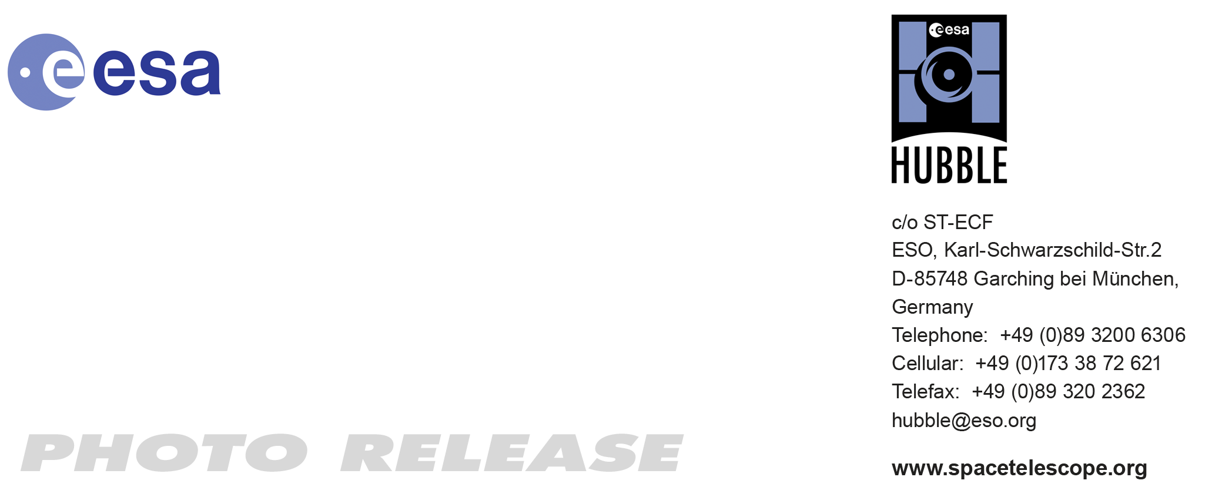

HEIC1006: EMBARGOED UNTIL 16:00 (CEST)/10:00 AM EST 08 April, 2010
http://www.spacetelescope.org/news/html/heic1006.html

Photo release: Hubble snaps heavyweight of the Leo Triplet

08-April-2010 Hubble has snapped a spectacular view of the largest “player” in the Leo Triplet, a galaxy with an unusual anatomy: it displays asymmetric spiral arms and an apparently displaced core. The peculiar anatomy is most likely caused by the gravitational pull of the other two members of the trio.

The unusual spiral galaxy, Messier 66, is located at a distance of about 35 million light-years in the constellation of Leo. Together with Messier 65 and NGC 3628, Messier 66 is one third of the Leo Triplet, a trio of interacting spiral galaxies, part of the larger Messier 66 group. Messier 66 wins out in size over its fellow triplets — it is about 100 000 light-years across.

Messier 66 is the proud owner of exclusive asymmetric spiral arms which seem to climb above the galaxy’s main disc and an apparently displaced nucleus. This asymmetry is unusual; most often, dense waves of gas, dust and newly born stars wind about the galaxy’s centre in a symmetric way. Astronomers believe that Messier 66’s once orderly shape has most likely been distorted by the gravitational pull of its two neighbours.

Hubble has imaged Messier 66’s striking dust lanes and bright star clusters along the spiral arms in fine detail with the Advanced Camera for Surveys. Star clusters — pictured in the blue and pinkish regions of the image — are key tools for astronomers since they are used as indicators of how the parent galaxies assembled over time.

Messier 66 boasts a remarkable record of supernovae explosions. The spiral galaxy has hosted three supernovae since 1989, the latest one occurring in 2009. A supernova is a stellar explosion that may momentarily outshine its entire host galaxy. It then fades away over a period lasting several weeks or months. During its very short life the supernova radiates as much energy as the Sun would radiate over a period of about 10 billion years.

# # #

Notes for editors
The Hubble Space Telescope is a project of international cooperation between ESA and NASA.

Image credit: NASA, ESA and the Hubble Heritage (STScI/AURA)-ESA/Hubble Collaboration. Acknowledgement: Davide De Martin and Robert Gendler

If you wish to no longer receive these News and Photo Releases, please send an e-mail to distribution@spacetelescope.org with your name.

For more information, please contact:

Colleen Sharkey
Hubble/ESA, Garching, Germany
Tel: +49-89-3200-6306
Cell: +49-0151-1537-3591
E-mail: csharkey@eso.org

