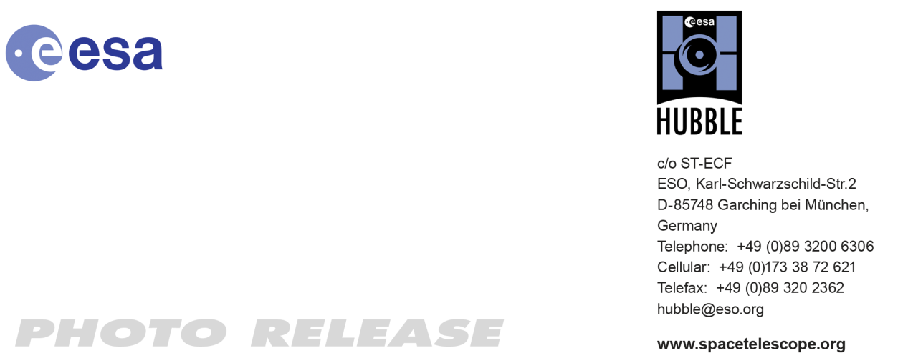

HEIC1018: FOR IMMEDIATE RELEASE 15:00 CET/09:00 am EST 14 December, 2010
http://www.spacetelescope.org/news/heic1018/

Photo release: Hubble spots a celestial bauble

14-Dec 2010 Hubble has spotted a festive bauble of gas in our neighbouring galaxy, the Large Magellanic Cloud. Formed in the aftermath of a supernova explosion that took place four centuries ago, this sphere of gas has been snapped in a series of observations made between 2006 and 2010.

The delicate shell, photographed by the NASA/ESA Hubble Space Telescope, appears to float serenely in the depths of space, but this apparent calm hides an inner turmoil. The gaseous envelope formed as the expanding blast wave and ejected material from a supernova tore through the nearby interstellar medium. Called SNR B0509-67.5 (or SNR 0509 for short), the bubble is the visible remnant of a powerful stellar explosion in the Large Magellanic Cloud (LMC), a small galaxy about 160 000 light-years from Earth.

Ripples seen in the shell’s surface may be caused either by subtle variations in the density of the ambient interstellar gas, or possibly be driven from the interior by fragments from the initial explosion. The bubble-shaped shroud of gas is 23 light-years across and is expanding at more than 18 million km/h.

Astronomers have concluded that the explosion was an example of an especially energetic and bright variety of supernova. Known as Type Ia, such supernova events are thought to result when a white dwarf star in a binary system robs its partner of material, taking on more mass than it is able to handle, so that it eventually explodes.

Hubble’s Advanced Camera for Surveys observed the supernova remnant on 28 October 2006 with a filter that isolates light from the glowing hydrogen seen in the expanding shell. These observations were then combined with visible-light images of the surrounding star field that were imaged with Hubble’s Wide Field Camera 3 on 4 November 2010.

With an age of about 400 years, the supernova might have been visible to southern hemisphere observers around the year 1600, although there are no known records of a “new star” in the direction of the LMC near that time. A much more recent supernova in the LMC, SN 1987A, did catch the eye of Earth viewers and continues to be studied with ground- and space-based telescopes, including Hubble.

# # #

Notes for editors
The Hubble Space Telescope is a project of international cooperation between ESA and NASA.

Image credit: NASA, ESA, and the Hubble Heritage Team (STScI/AURA). Acknowledgement: J. Hughes (Rutgers University)

For more information, please contact

Oli Usher
Hubble/ESA, Garching, Germany
Tel: +49-89-3200-6855
E-mail: ousher@eso.org

Ray Villard
Space Telescope Science Institute, Baltimore, USA
Tel: +1-410-338-4514
E-mail: villard@stsci.edu

Keith Noll
Space Telescope Science Institute, Baltimore, USA
Tel: +1-410-338-1828
Email: noll@stsci.edu

