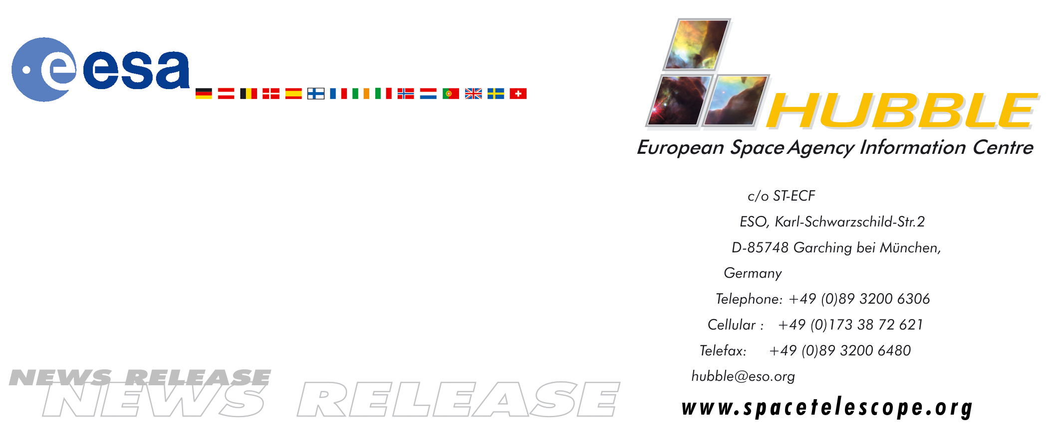
HEIC9903

News release:
The 'Rotten Egg' nebula - a planetary nebula in the making

19-Oct-1999: The object shown in these ESA/NASA Hubble Space Telescope images is a remarkable example of a star going through death throes just as it dramatically transforms itself from a normal red giant star into a planetary nebula. This process happens so quickly that it is quite rare to observe such objects, even though astronomers believe that most stars like the Sun will eventually go through such a phase.

This star, with the prosaic name of OH231.8+4.2, is seen in these infrared pictures blowing out gas and dust in two opposite directions. So much dust has been cast off and now surrounds the star that it cannot be seen directly, only its starlight that is reflected off the dust. The flow of gas is very fast, with a velocity up to 700 000 km/h. With extreme clarity, these Hubble Near Infrared Camera and Multi-Object Spectrometer (NICMOS) images reveal that the fast-moving gas and dust are being collimated into several thin streamers (on the right) and a jet-like structure (on the left), which can be seen extending away from the centers of both pictures. On the right, wisps of material in jet-like streamers appear to strike some dense blobs of gas. This interaction must produce strong shock waves in the gas.

The pictures represent two views of the object. The colour image is a composite of four images taken with different NICMOS infrared filters on 28 March, 1998. It shows that the physical properties of the material, both composition and temperature, vary significantly throughout the outflowing material. The black-and-white image was taken with one NICMOS infrared filter. That image is able to show more clearly the faint detail and structure in the nebula than can be achieved with the colour composites.

Observations by radio astronomers have found many unusual molecules in the gas around this star, including many containing sulphur, such as hydrogen sulphide and sulphur dioxide. These sulphur compounds are believed to be produced in the shock waves passing through the gas. Because of the large amount of sulphur compounds, this object has earned the nickname 'The Rotten Egg' Nebula. It resides in the constellation Puppis.

These NICMOS data pose a serious challenge to astrophysical theorists: How can a star generate such tightly collimated streams of gas and dust and accelerate them to such very high velocities? William B. Latter from the California Institute of Technology and his group are using these data to obtain a better understanding of the detailed structure in the outflowing material, look for evidence for the origin of the thin streamers and jets, and learn more about the star itself. This information will give astronomers a more complete understanding of the final stages in the life of stars like our Sun.

These results were presented at a conference called 'Asymmetrical Planetary Nebulae II: From Origins to Microstructures,' Aug. 3 to 6, 1999 at the Massachusetts Institute of Technology. The results will also be published in the Astrophysical Journal.

This news note has been prepared in collaboration with Office of Public Outreach at ST ScI (Ray Villard).

# # #
Note to editors:
The Hubble Space Telescope is a project of international cooperation between NASA and ESA.

For more information, please contact:
Lars Lindberg Christensen
ST-ECF
Garching, Germany
Phone: +49-89-3200-6306
Fax: +49-89-3200-6480
E-mail: lars@eso.org

William B. Latter
SIRTF Science Center/California
Institute of Technology
(phone: 626-395-8568, fax: 626-568-0673)

