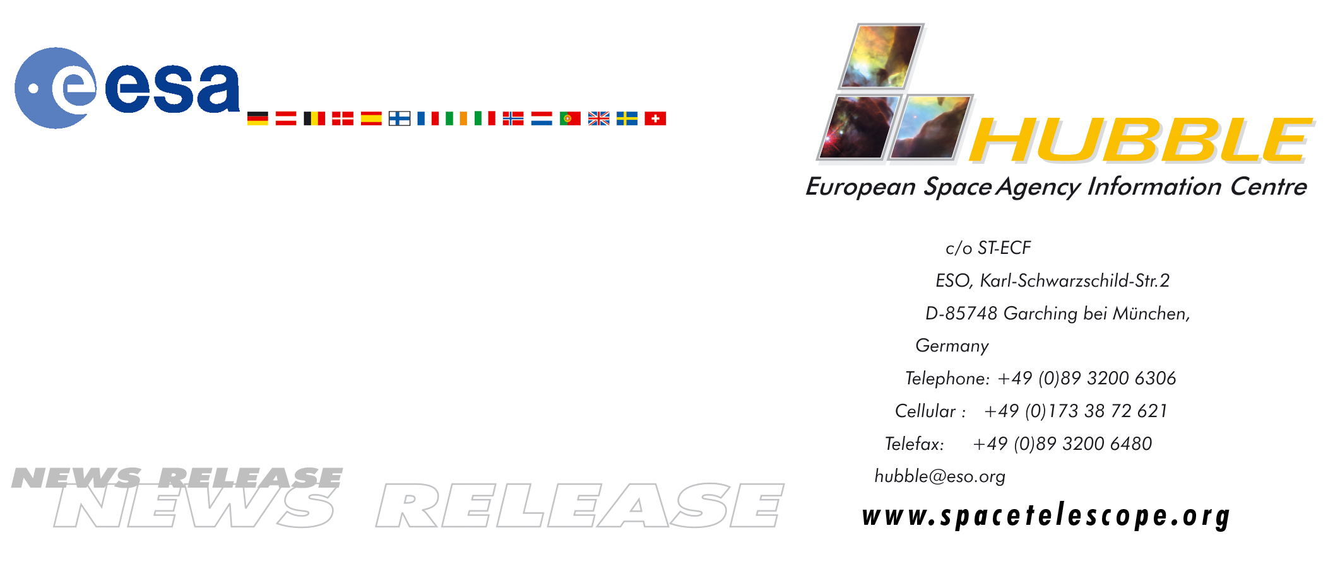
HEIC9904

News release:
Hubble Space Telescope into safe hold as gyroscope fails

16-Nov-1999: Just 24 days before its third Servicing Mission, the Hubble Space telescope has been placed into a safe mode, triggered by a failure in one of Hubble's last three working gyroscopes.

The safe mode occurred on Saturday 13 November at approximately 14:00 CET (13:00 UT), and this essentially means that the telescope is now in hibernation. This protective safe mode allows ground control of the telescope, but with only two gyros working, Hubble cannot be aimed with the precision necessary for scientific observations of the sky. The Hubble science programme has therefore been suspended until the coming Servicing Mission in early December.

The original six gyroscopes have been the cause of some concern for NASA and ESA officials and astronomers on both continents. The first gyro failed in 1997, the second in 1998, and the third in 1999. Even if another gyro should fail in the next few weeks, HST will remain safe. The aperture door has been closed to protect the optics and the spacecraft is aligned to the sun to ensure adequate power is received by its solar panels.

The third Servicing Mission, originally planned for June 2000, was split into two missions - SM3A and SM3B - in part due to the complexity involved, and in part due to the urgency of replacing the failing gyroscopes onboard. It is now clear that it was a very wise decision to speed up the mission, and the fact that HST is now in safe mode stresses even more clearly the importance of SM3A.

The Hubble Space Telescope is a project of international cooperation between NASA and ESA. ESA has a special interest in the next Servicing Mission since two European astronauts will work on fixing Hubble. French astronaut Jean-Francois Clervoy will maneouvre the Space Shuttle's robotic arm during the mission. He will, among other things, have the demanding task of capturing and releasing the Telescope. Claude Nicollier from Switzerland is visiting Hubble for the second time since he flew on the first Servicing Mission. Nicollier will be replacing some of Hubble's parts during some of the mission's spacewalks (also known as EVAs - Extra Vehicular Activities).

Looking back at almost ten years of Hubble observations, ESA's Head of ST-ECF, European HST Project Scientist Piero Benvenuti states:
“Hubble is of paramount importance to European astronomy. It gives the opportunity for European scientists to use a top class instrument that Europe alone would not have been able to build and operate. In specific areas of research they have now, mainly due to HST, achieved international leadership.”

# # #
Note to editors:
ST-ECF can provide comments in most European languages. Please direct your inquiries to the above-mentioned contacts.

For more information, please contact:
European Public Outreach Scientist Lars Lindberg Christensen
Space Telescope-European Coordinating Facility (ST-ECF)
Garching, Germany
Phone: +49-89-3200-6306
Fax: +49-89-3200-6480
E-mail: lars@eso.org

ESA's HST European Project Scientist
Piero Benvenuti
ST-ECF
Phone: +49-89-3200-6291
Fax: +49-89-3200-6480
E-mail: piero@eso.org

