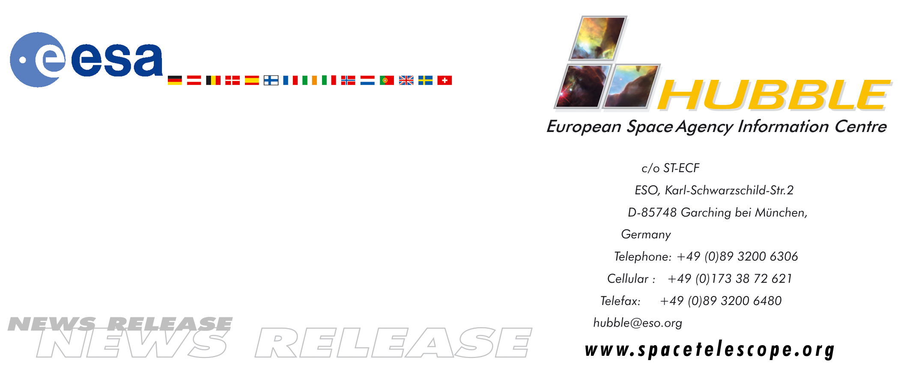
HEIC9906

News release:
European astronauts set for Hubble challenge

09-Dec-1999: Two of the European Space Agency's most experienced astronauts are preparing to board the Space Shuttle Discovery as part of the international crew to be launched on an end-of-the-year mission to service the Hubble Space Telescope.

Swiss-born Claude Nicollier will become the first European to make a 'spacewalk' from the Space Shuttle. Frenchman Jean-Frangois Clervoy, chief operator of the Shuttle's robotic arm, will capture the telescope and release it once work has been completed.

The mission's main objective is to replace Hubble's failed pointing system, which allows astronomers to aim the telescope very precisely at stars, planets and other distant astronomical objects.

During 10 days in orbit, astronauts will undertake four 'spacewalks' to update and renew equipment. Nicollier will achieve the ambition of a lifetime when he exits the airlock at the beginning of the mission's second major spacewalk in the early hours of 16 December on his first six-hour stint carrying out repairs on the two-storey high Hubble telescope.

The opportunity for one of its astronaut to make two spacewalks during the mission is important for ESA. “It is a question of building up experience. We have had EVAs (Extra Vehicular Activities) from Mir but this will be the first time a European has had the opportunity to go from the Shuttle,” said Nicollier.

Nicollier is on his fourth flight into space. Among them he took part in the first Hubble servicing mission in 1993, controlling the Shuttle's robotic arm while astronauts outside performed repairs to the telescope. This time Clervoy, on his third flight, will have that lead role in the operation of the robotic arm.

About 48 hours after launch, Clervoy will take the controls, extend the Shuttle's arm and gently attach it to a fixture on Hubble as the two hurtle round the Earth in tandem at speeds of 27,000 km an hour.

There is no room for mistakes as he performs a task in real time that he has practised for many hours in simulations on the ground. After attaching the arm, he will slowly guide the 12-ton telescope to its repair berth at the rear of the Shuttle's payload bay.

Clervoy flew in space for the first time on the Space Shuttle Atlantis in November 1994 and the experience gained on that flight - when he controlled the robotic arm to deploy an atmospheric research satellite for the German space agency DLR - will be invaluable.

Notes on the Hubble Space Telescope

The Hubble Space Telescope was launched in 1990 with an expected orbital lifetime of 20 years. ESA contributed a 15 percent share to its development and in return European astronomers receive a guaranteed 15 percent share of observing time. In reality this has averaged 20 percent because of the high quality of proposals from scientists in Europe.

A servicing mission had been scheduled for June 2000 but after three of the telescope's six gyroscopes failed NASA officials decided not to risk waiting. Hubble requires three of its six gyroscopes to operate properly for accurate stabilisation but a fourth failed in November - posing no long term threat to the telescope but meaning observations had to be suspended until the replacements are fitted.

As well as replacing all the telescope's gyros, the crew will install other equipment that has either degraded in the harsh space environment or can now be replaced with more up-to-date technology.
.

# # #

For more information, please contact:
Lars Lindberg Christensen
Hubble European Space Agency Information Centre, Garching, Germany
Phone: +49-(0)89-3200-6306
Cellular (24 hr): +49-(0)173-38-72-621
E-mail:lars@eso.org

