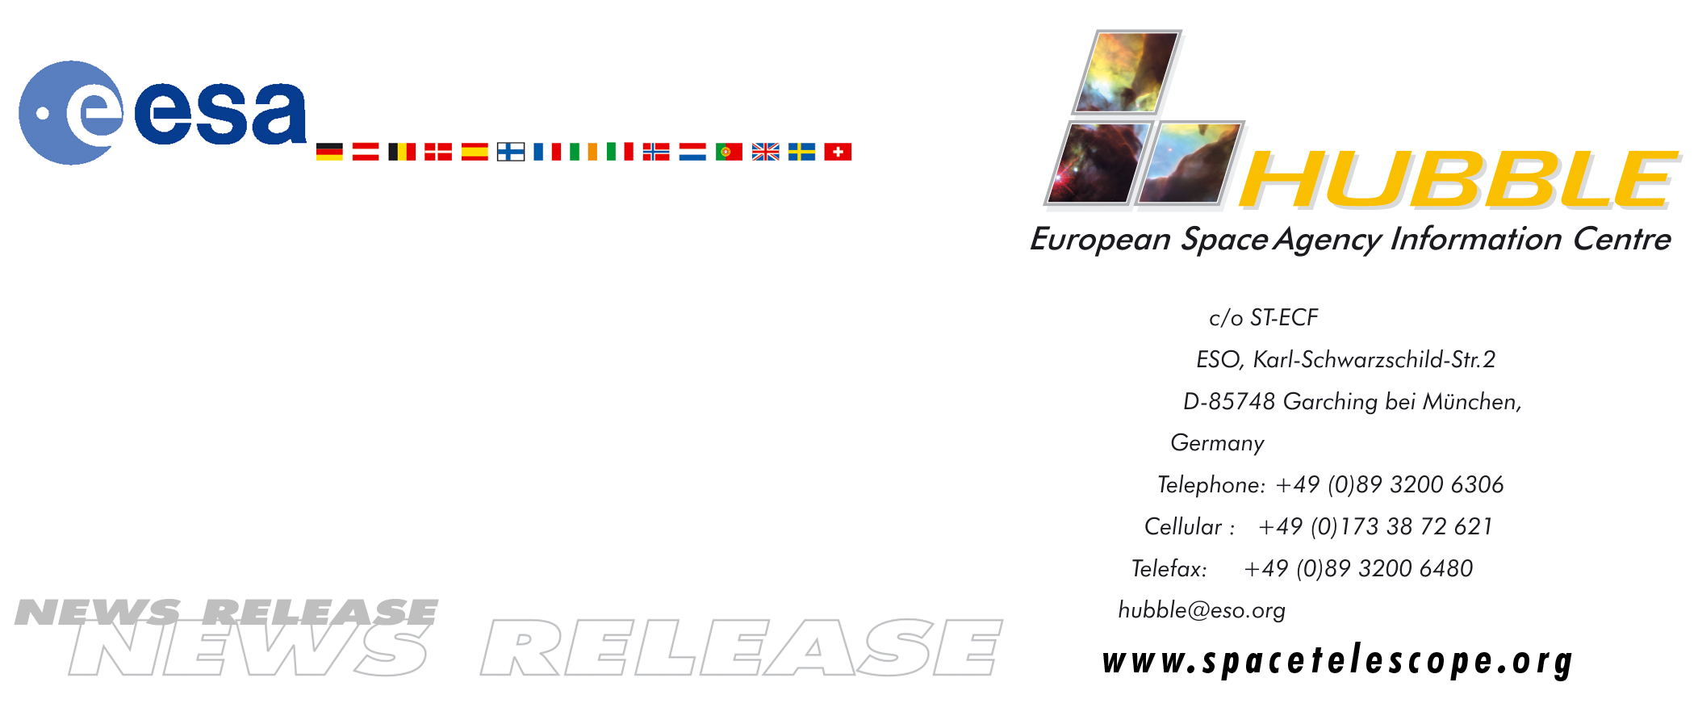
HEIC9908

News release:
ESA's Hubble duo back on Earth after successful servicing mission

28-Dec-1999: ESA astronauts Claude Nicollier and Jean-Frangois Clervoy and their five fellow crew members on the Space Shuttle Discovery returned to Earth today (28 December at 0001 GMT) after a spectacular mission to service the Hubble Space Telescope.

European astronomers breathed a collective sigh of relief as the giant orbiting observatory was gently returned to orbit at the end of the busy eight-day mission.

During the flight, Nicollier became the first European astronaut to walk in space from the Shuttle as he worked with British-born astronaut Michael Foale on a six-hour stint in space. On the second of three EVA days, Nicollier and Foale successfully replaced the telescope's computer, dramatically increasing Hubble's capabilities and significantly cutting operational costs.

Clervoy, the mission flight engineer, proved his expertise as the main operator of the Shuttle's robotic arm providing the platform used during the space walks to manoeuvre astronauts around the telescope in the orbiter's payload bay.

The mission's prime objective was to replace the telescope's six gyroscopes (three of which must be working to meet the telescope's very precise pointing requirements). Since November, the telescope has not been operating, after a fourth gyroscope failed. The telescope will be tested over the next two or three weeks.

As well as replacing all the telescope's gyros, the crew also replaced other equipment on Hubble that had either degraded in the harsh space environment or could be replaced with more up-to-date technology.

# # #

For more information, please contact:
ESA Public Relations Division
Tel: +33(0)1.53.69.7155
Fax: +33(0)1.53.69.7690

