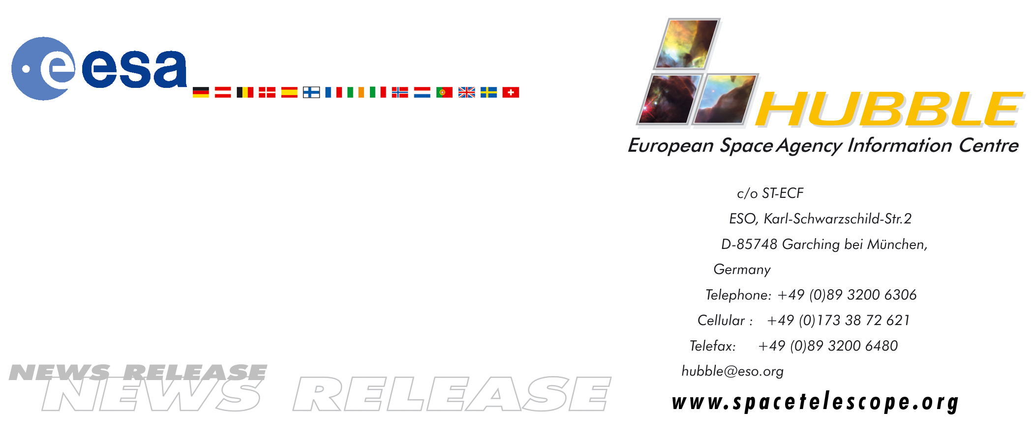
HEIC9911

News release:
The Heliosphere is Tilted - implications for the 'Galactic weather forecast'?

13-Mar-2000: Supersonic shock waves detected at the edge of the Solar System - a new study by European scientists clarifies conditions at our Earth's outermost shield against interstellar charged particles.

The local interstellar cloud
Our Solar System entered an interstellar cloud 10,000 years ago. Today it is speeding through this nebulosity at Mach 2 behind a supersonic shock wave - in much the same way that a Concorde crosses the Atlantic at supersonic speed. Since its formation 4.6 billion years ago our Solar System has encountered numerous interstellar clouds, knots, filaments, shells and bubbles of different sizes and contents on its path through the Milky Way. For more than 80 years astronomers have been attracted by these past and future encounters, have tried to understand the physics behind them in order to decipher the dynamic interplay between the interstellar material and the Solar System.

There is some chance that the Solar System will cross small dense clouds that have diameters up to 100 times the distance from the Earth to the Sun. These encounters may increase the number of interstellar charged particles bombarding Earth, with the risk of altering the climate here. Our interstellar environment may thus be important for the short and long-term prospects for life on Earth. Even though there is still some work to be done before it will be possible to construct a 'Galactic weather forecast', it is clear that for the past 200,000 years we have been in a favourable environment that has not altered our climate significantly. Recent studies by a group of European scientists of the conditions at the outermost edge of the Solar System using the NASA/ESA Hubble Space Telescope and Voyager have shown some surprising results.

The heliosphere
Charged particles from the Sun spiral out into space and form the solar wind. The solar wind particles follow the lines of the solar magnetic field and fill a region of space called the Heliosphere that encloses the Solar System. The solar particles at the edge of the heliosphere form a barrier to deflect other incoming charged particles and so partially protect the inner Solar System from the surrounding interstellar medium. The motion of the Solar System through the dust, gas and nebulosity that make up the interstellar medium give the heliosphere a comet-like shape with a head and a tail. At the leading edge of the heliosphere, atoms and ions from the interstellar medium slow down as they approach the head, forming a shock wave, known as the interstellar bow shock. As the leader of the group of scientists, French astrophysicist from the Institut d'Astrophysique de Paris, Lotfi Ben Jaffel, explains: “The bow shock has been predicted for more than 30 years, but its existence has so far been questionable. Now it seems that we have proof”.

The observations
Recent analysis of observations made in the far ultraviolet with Hubble's Goddard High Resolution Spectrograph (GHRS) has been carried out by the international group of scientists. By combining measurements from the Hubble Space Telescope with Voyager measurements, the scientists have not only located the interstellar bow shock, but have also discovered that the nose of the heliosphere points 120 away from the direction from which the local cloud is approaching. In this way the group has been able to determine the direction of the interstellar magnetic field which causes this 120 tilt.

By observing regions free of bright stars and galaxies, the team were able to detect a feeble ultraviolet glow called the Fermi glow, which arises when incoming light from stars and the Sun passes through the violent transition region between the heliosphere and the surrounding interstellar medium. By studying this faint glow and combining the data with intensity measurements from Voyager, Lotfi Ben Jaffel and his team have been able to deduce the direction of the interstellar magnetic field based on the observed inclination of the heliosphere. This discovery is highly significant as Ben Jaffel argues: “For many years it has been thought that the charged particles from the interstellar medium were hitting the heliosphere head-on. Now we see that these ions are deflected by the interstellar magnetic field. Only by understanding the processes at the boundary of the Solar System can we realise what influence the interstellar medium may have on our planet”.

The next step - an interstellar probe
It has been a long-standing dream for the scientists to make direct measurements of both the heliosphere and the interstellar medium with a probe. This dream may well come true. Scientists are currently investigating the different particles of interstellar origin that have reached the inner heliosphere using the ESA/NASA solar explorers Ulysses and SOHO. In the long-term, NASA is working on plans to send a probe to investigate the boundary between the Solar System and the interstellar medium. This so-called 'Interstellar Probe' will fly into the region of the bow shock closest to Earth and try to clarify the complex interactions occurring at this boundary. The scientists are excited at the prospects: “Such a probe will explore the nature of the interstellar medium and help predict the long-term influence of charged particles from the Milky Way on our weather and climate”. They add: “The new results from Hubble and Voyager will undoubtedly influence the design of the 'Interstellar Probe' and help pinpoint the regions of greatest scientific interest”.

# # #

Notes for editors
The Hubble Space Telescope is a project of international co-operation between NASA and ESA.

